BOITIER SOMFY 2400581

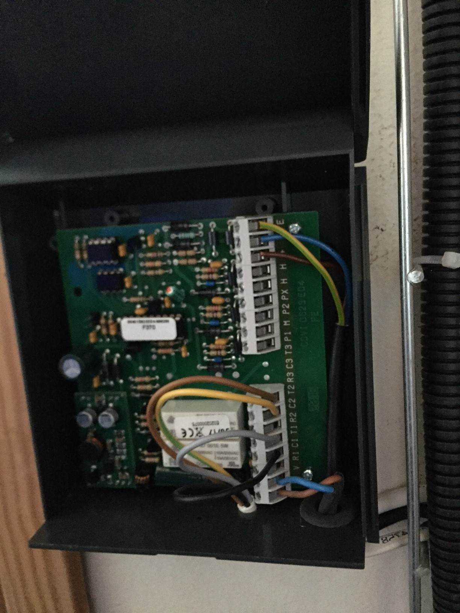
V :Raccordé sur le bus (4)
V : Raccordé sur le bus (3)
Relais RL1 (T1) ?
Relais RL1 (T1) ?
Relais RL2 (C2) ?
Relais RL2 (T2) ?
(+) : raccordé avec le blanc du clavier
(-) : raccordé avec le marron du clavier
(E) : raccordé avec le vert du clavier

