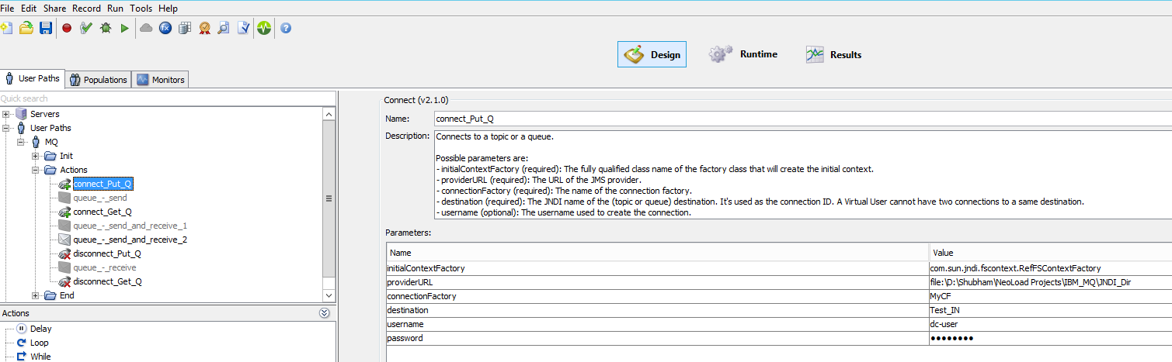
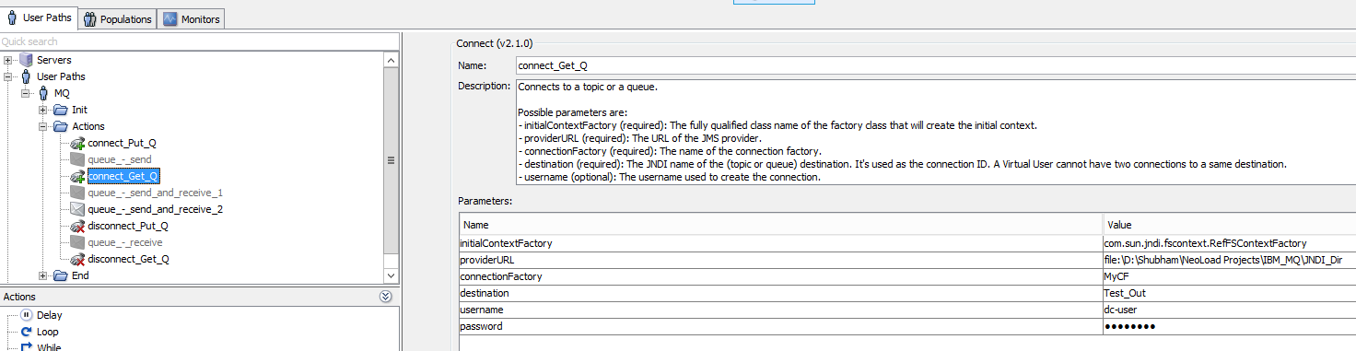
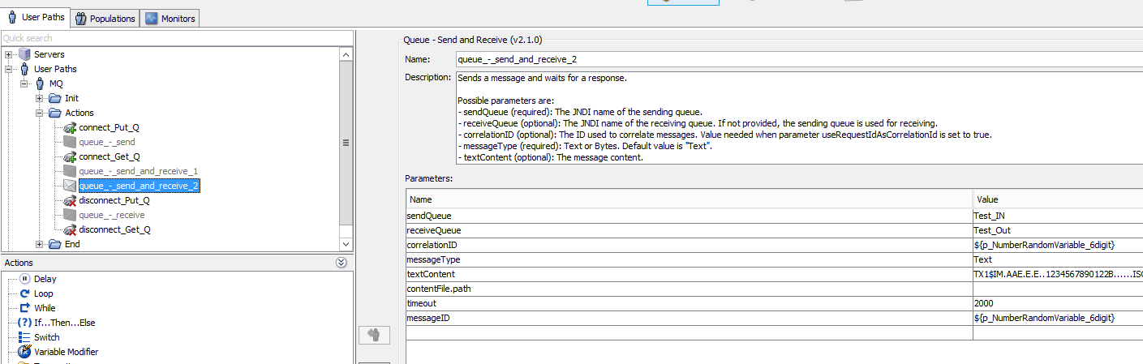

Replay Result-
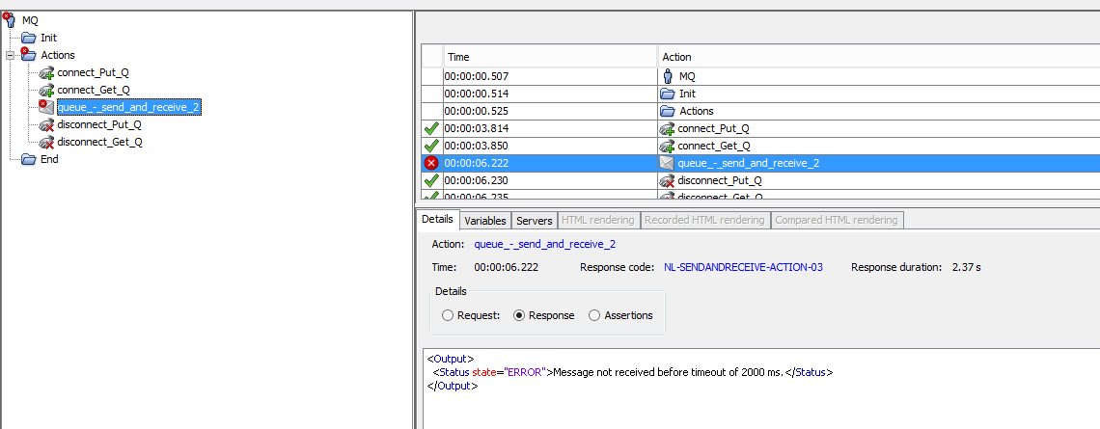
FYI: Queue configuration is fine and working properly. As well as, we are able to get message by other application.
But for performance testing we wanted to use Neoload to put and get message.

