Amerika Tecnologías de la Información is a company of the INASSA corporate group, and is specialized in implementing technology solutions for public utilities. We are an Oracle ISV and Gold Partner, and we have the quality certificate ISO 9001:2008.

The version 3.2 of our software, AMERIKA, has been implemented in six latin american countries, and supports the operation of fresh water and waste water public utilities in more than 37 cities, using a SaaS model.

AMERIKA is developed in Oracle Fusion Middleware 11g, and works on an Oracle Db Standard or Enterprise Edition Database, with any of these OS: Windows 2003, 2008, 2012 Server, AIX, HP - UX, HP Alpha, Linux, Solaris. Clients in a web platform can have access to the software using IE8 or superior, Mozilla Firefox 22 or superior.

We've been checking different automation and load testing tools. Since we basically have the same software implemented in our clients, it is crucial for us to use a tool that allows to make a recording in just one url, and then run it on any other client's url. We don't want to make the same recording on each client we have.

We've used NeoLoad, but we experienced issues when we create a virtual user on an URL, and then we run it on a different URL. The oracle forms, the database structures and even the data itself are the same on these URLs. We'd like to have your support to verify what we are doing.
This is what we are doing:
1. We create a new NeoLoad Project
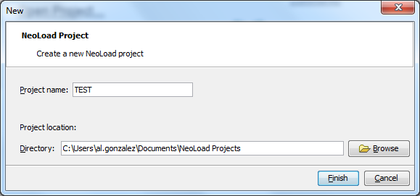
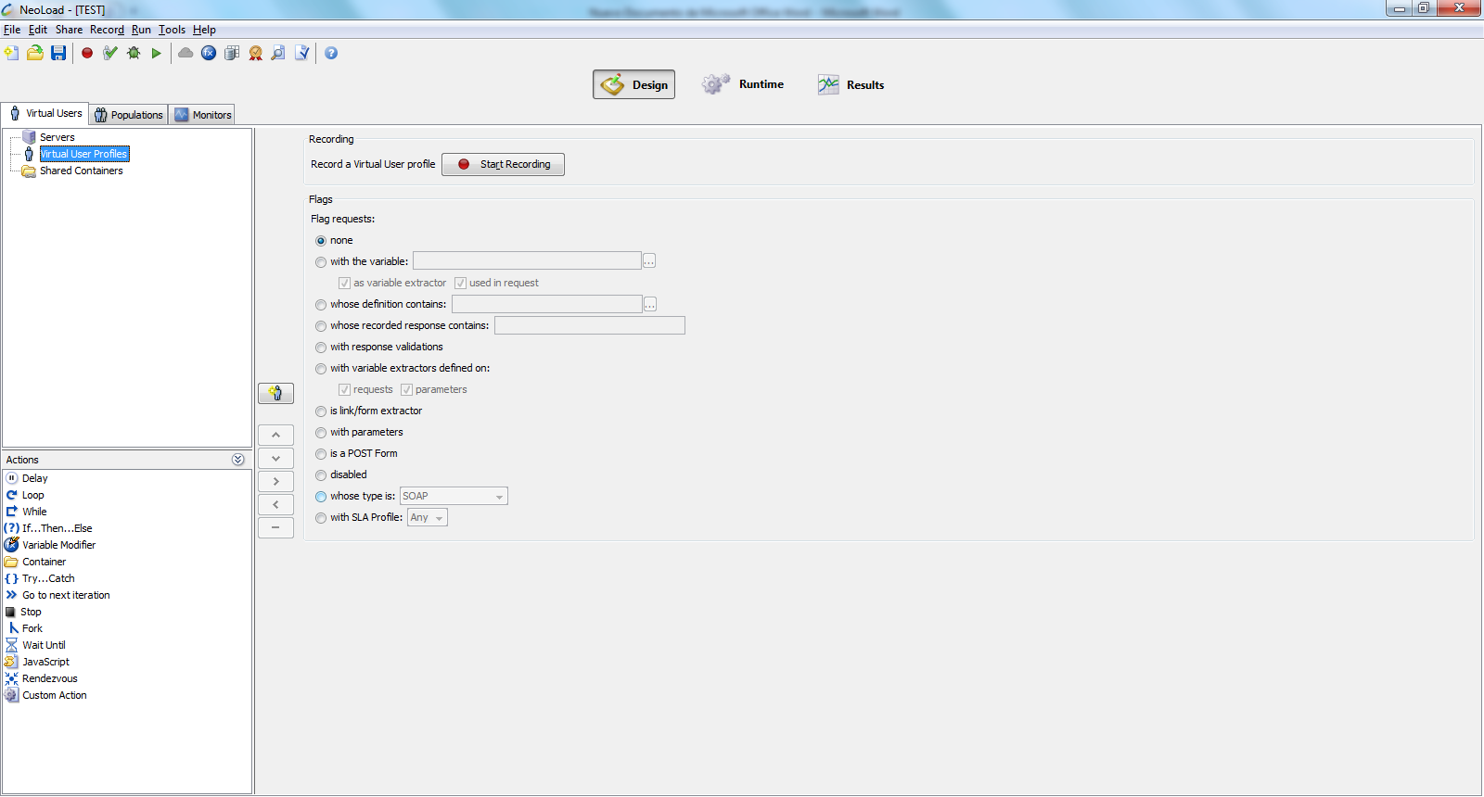

2. We create a new virtual user using the URL (Oracle Forms) http://10.6.6.170:8888/forms/frmservlet?config=amerika. Then we start the recording
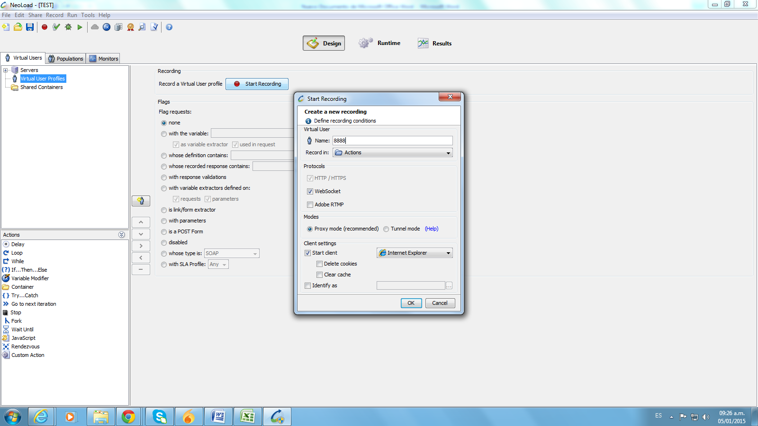
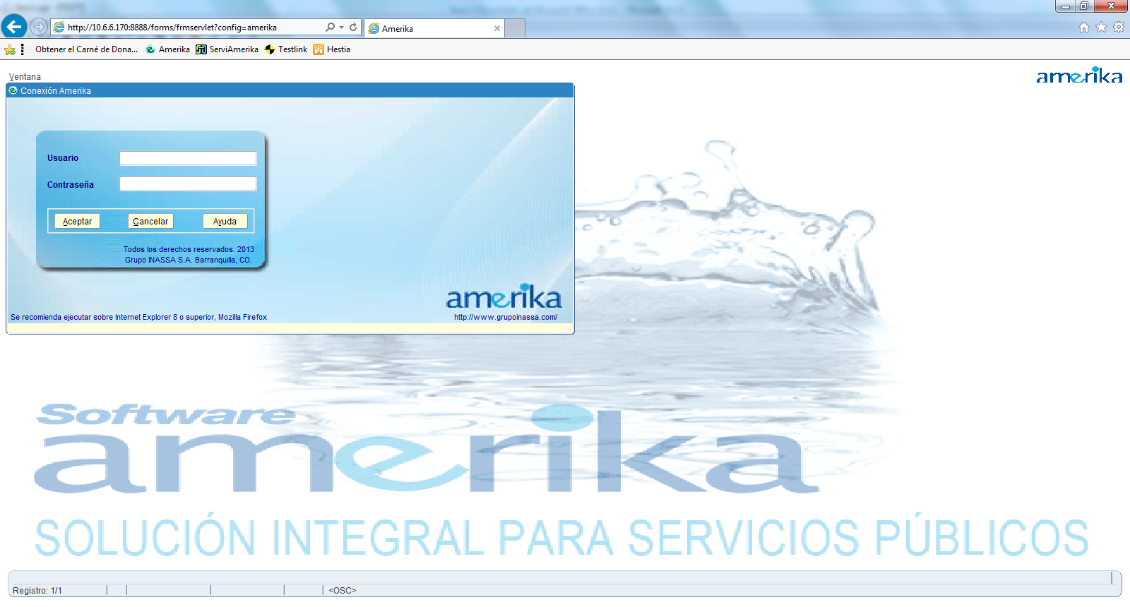
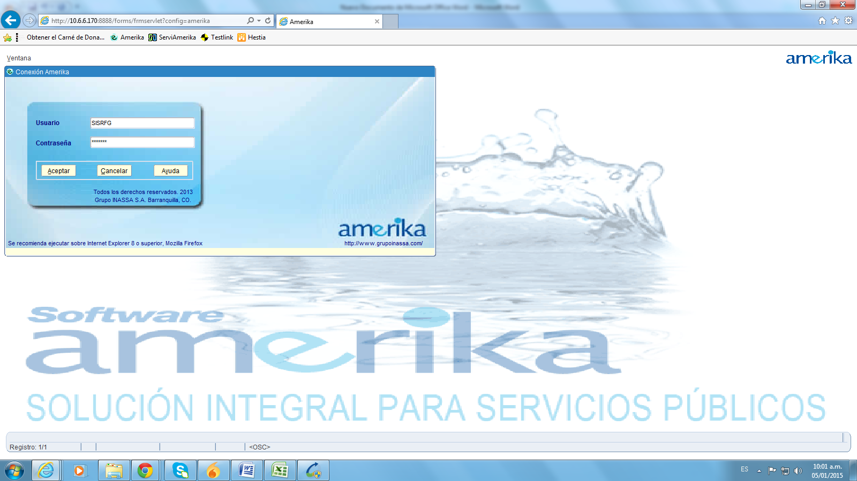
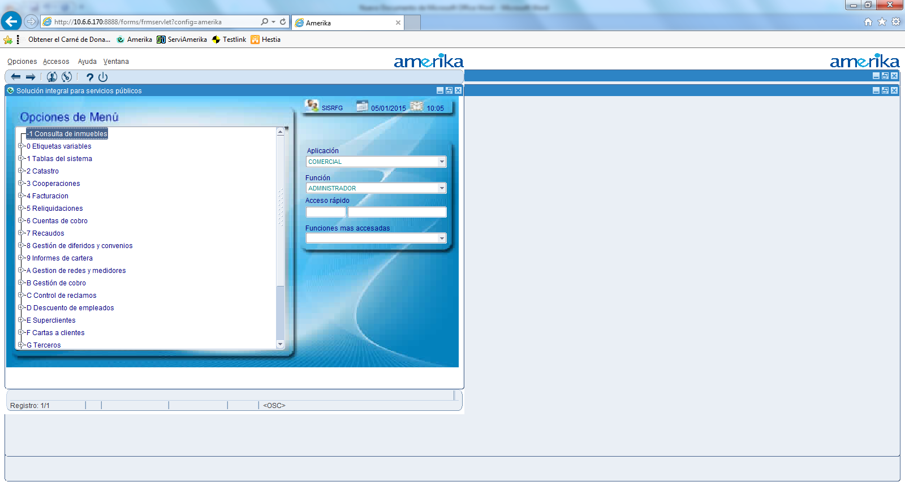
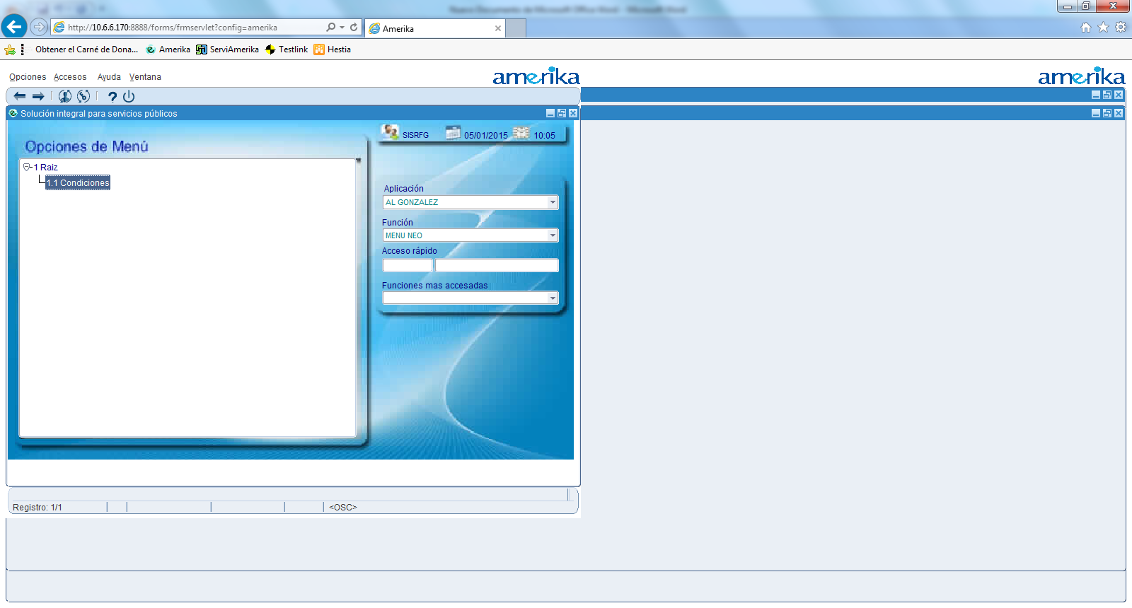
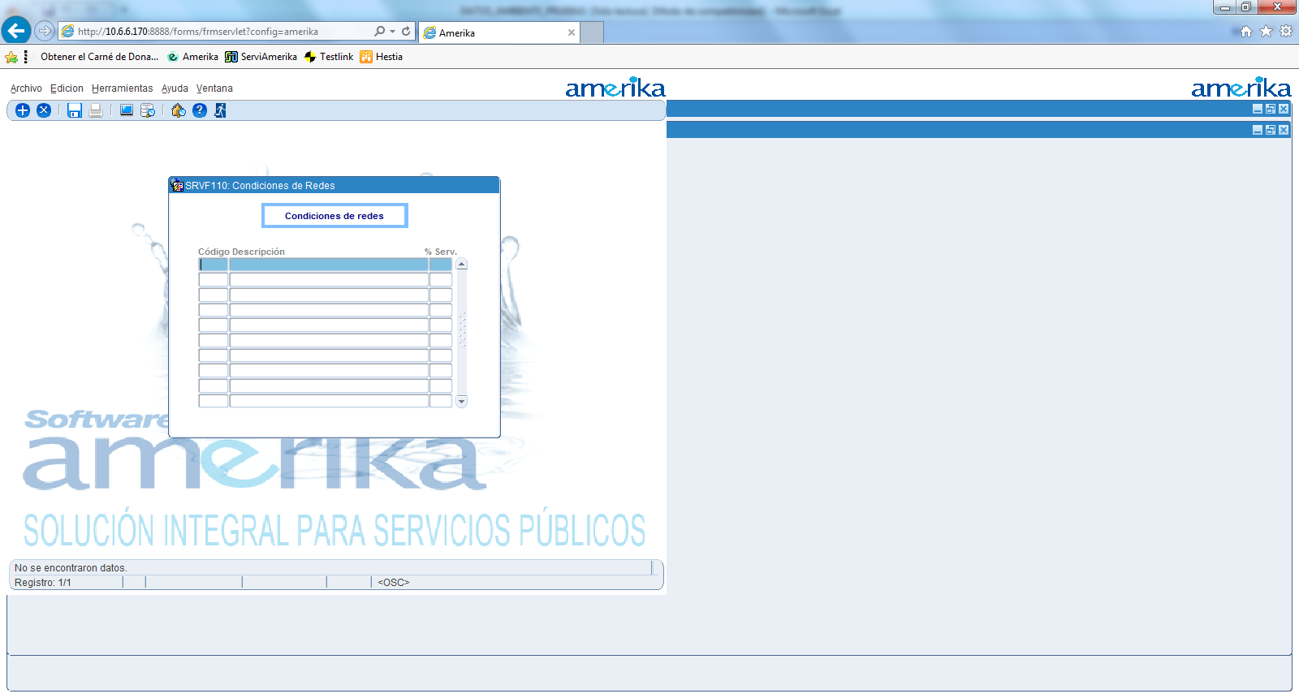

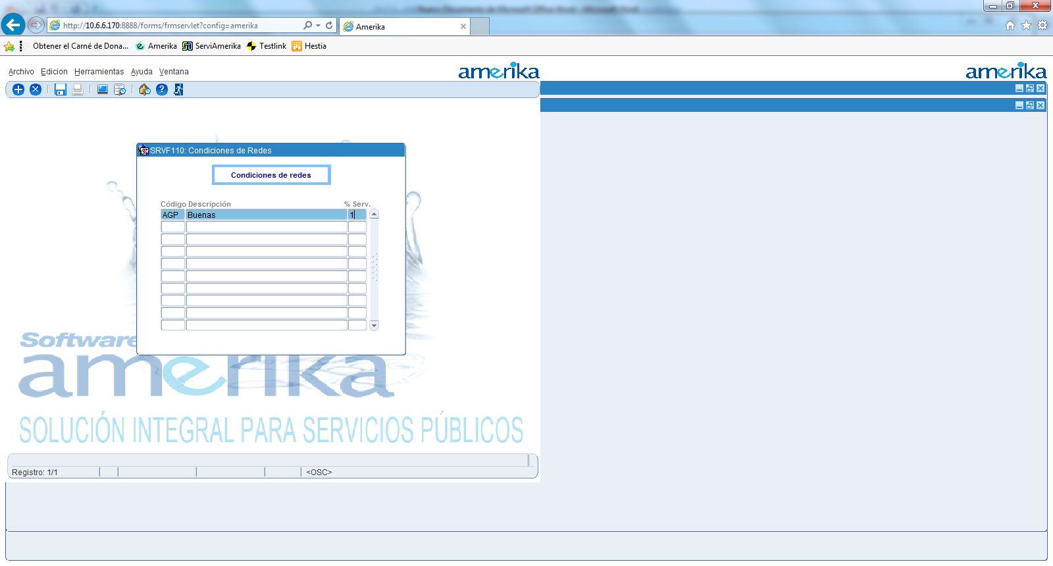
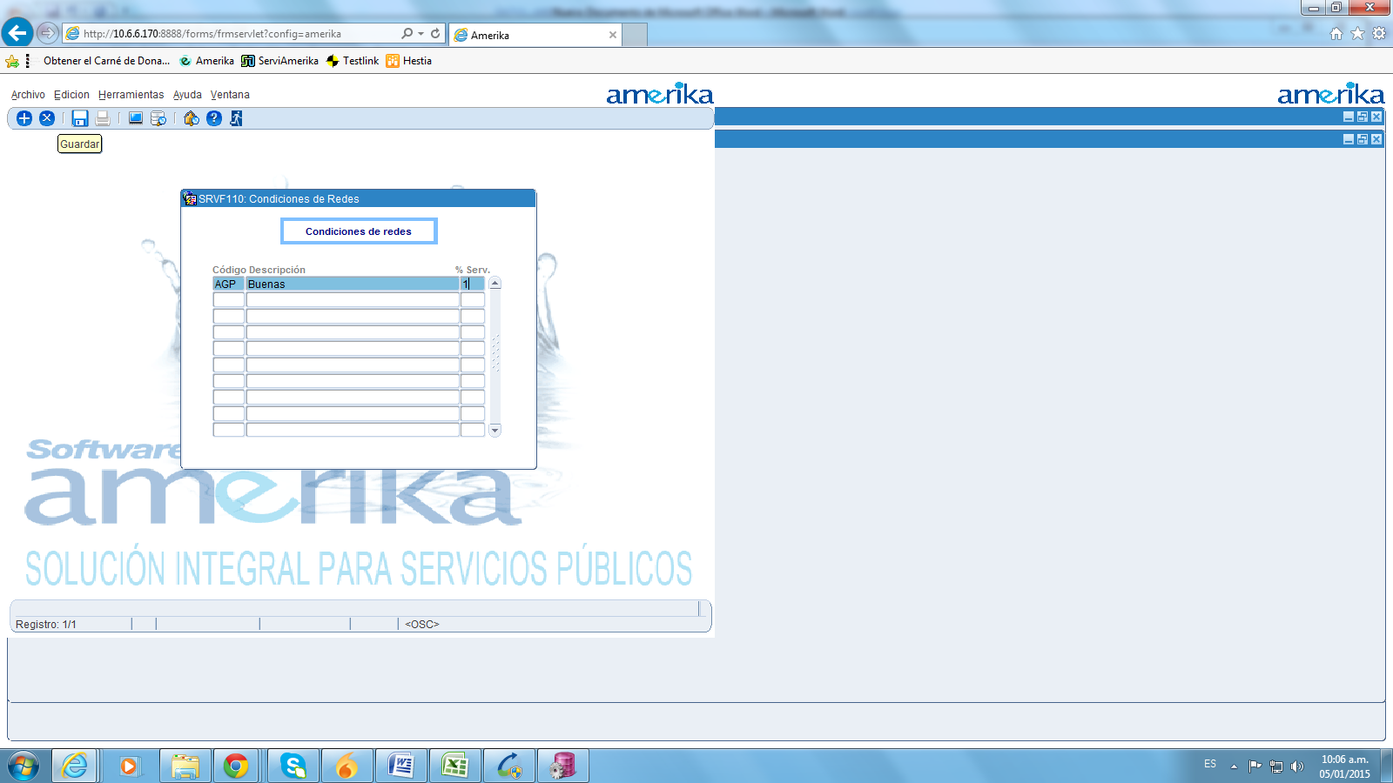
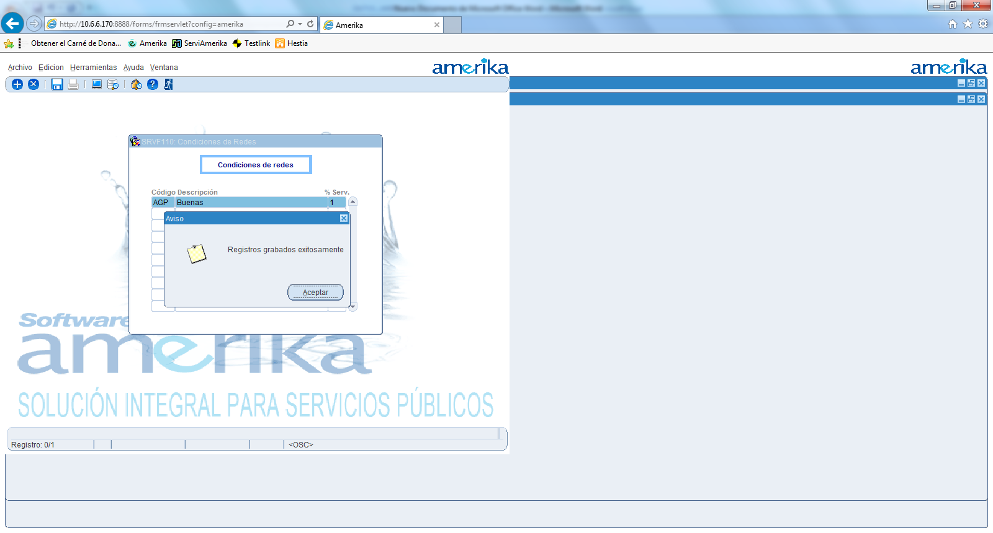
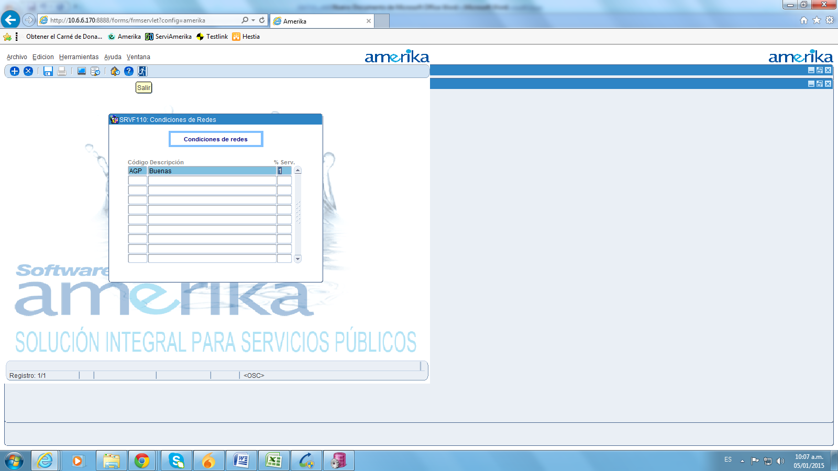
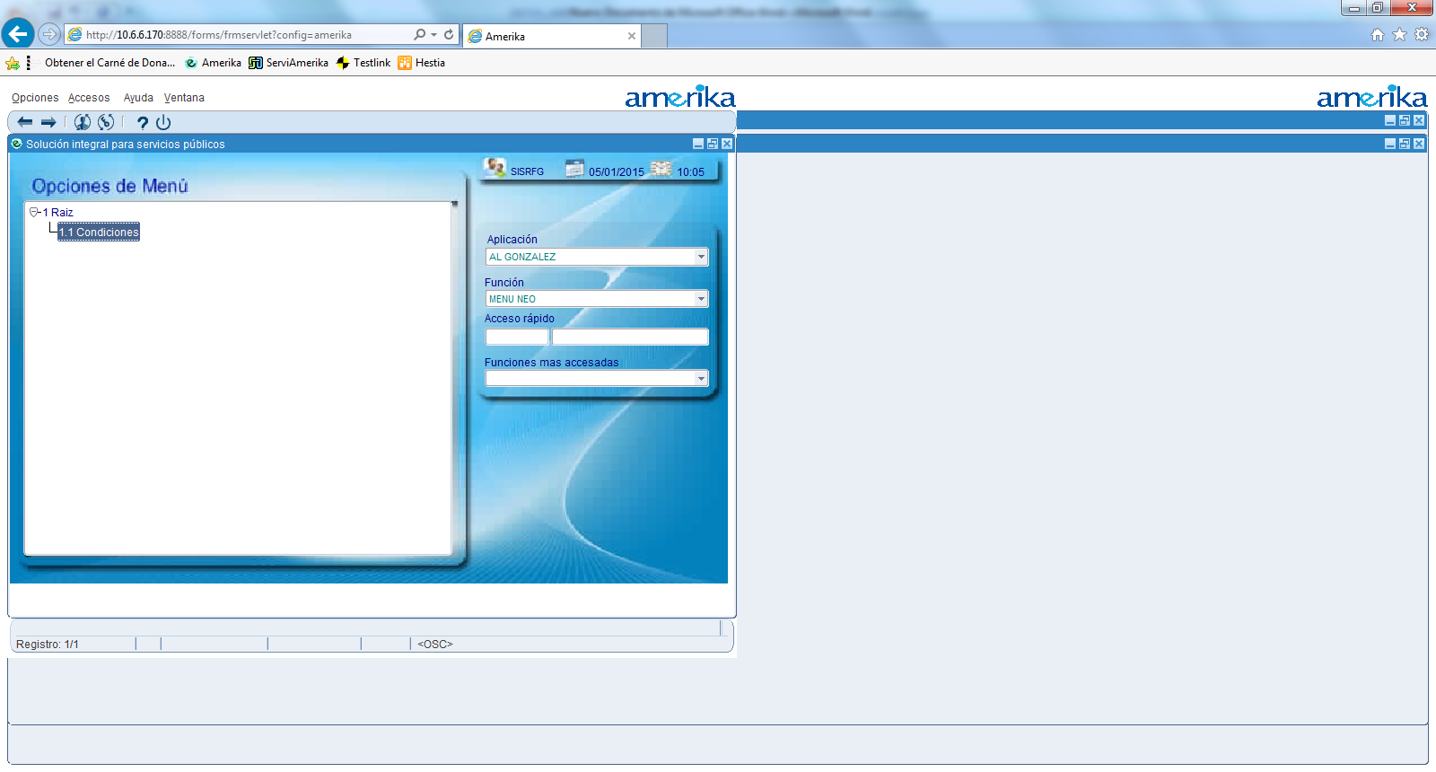
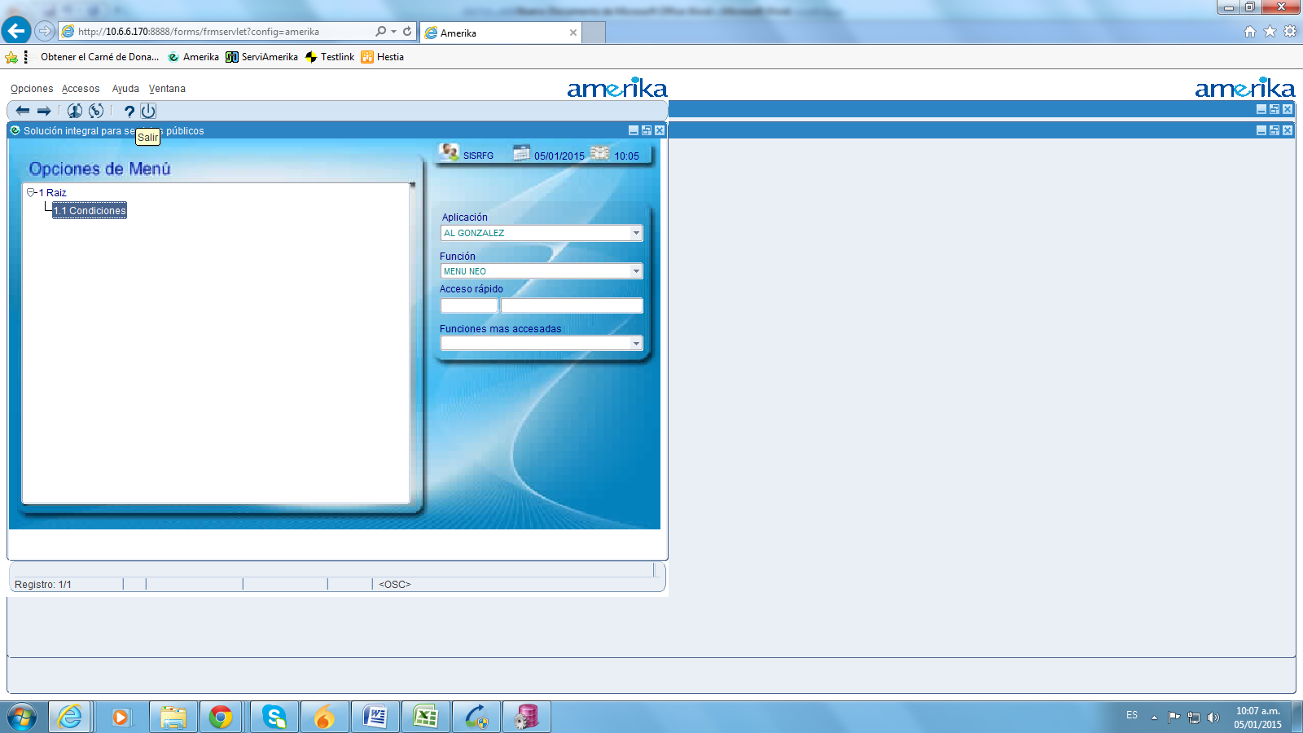
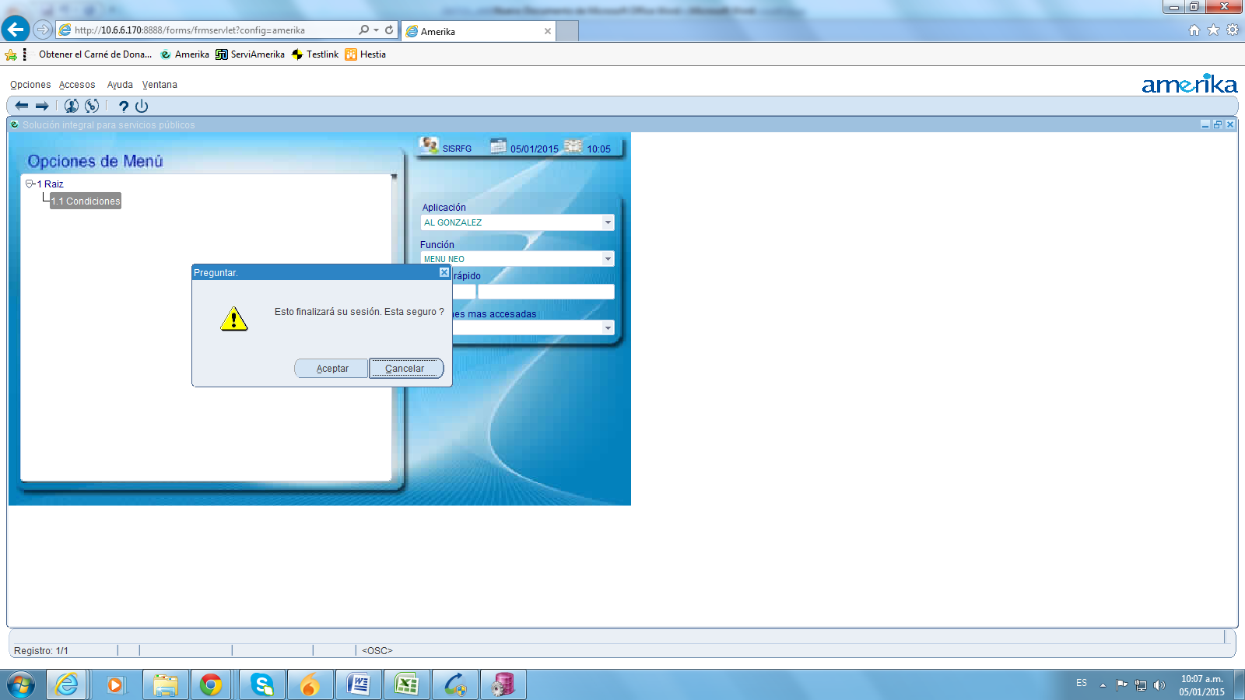
Neo creates the virtual user 8888 and the server 10.6.6.170. We successfully check the virtual user validity.
3. We have several customers and they run the same application. The only thing that changes is the URL. We want to make just one recording using any of the URLs, so we can reuse it later with any other customer URLs (or even in our own different environments, for example development, test, etc.). We have almost ten (10) customers and lots of local environments, that's why is crucial for us to reuse a recording.
We've tried to use the virtual user 8888 with another URL (http://10.6.6.170:8891/forms/frmservlet?config=amerika).
1. We create a copy of the virtual user.
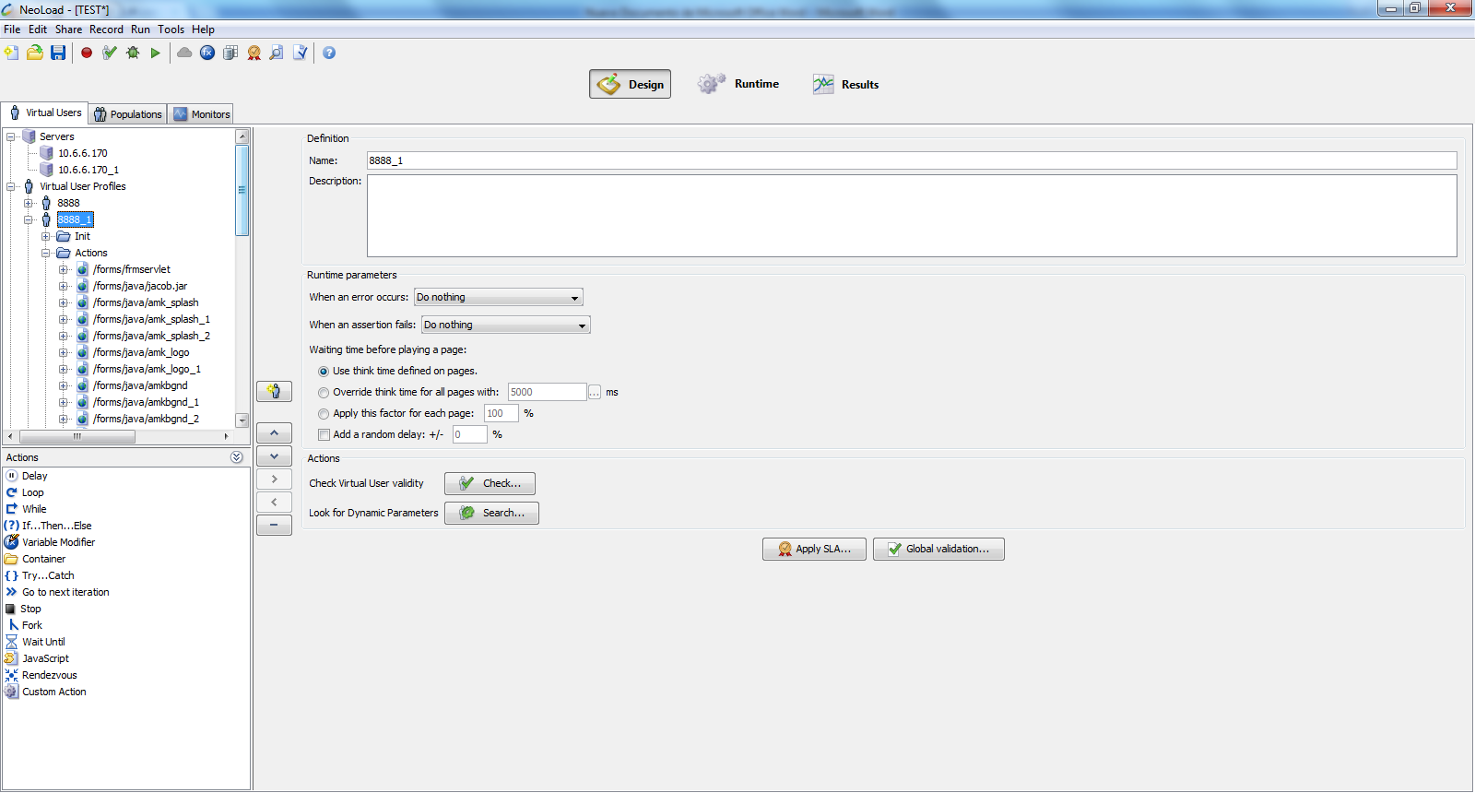
2. We also create the new server.
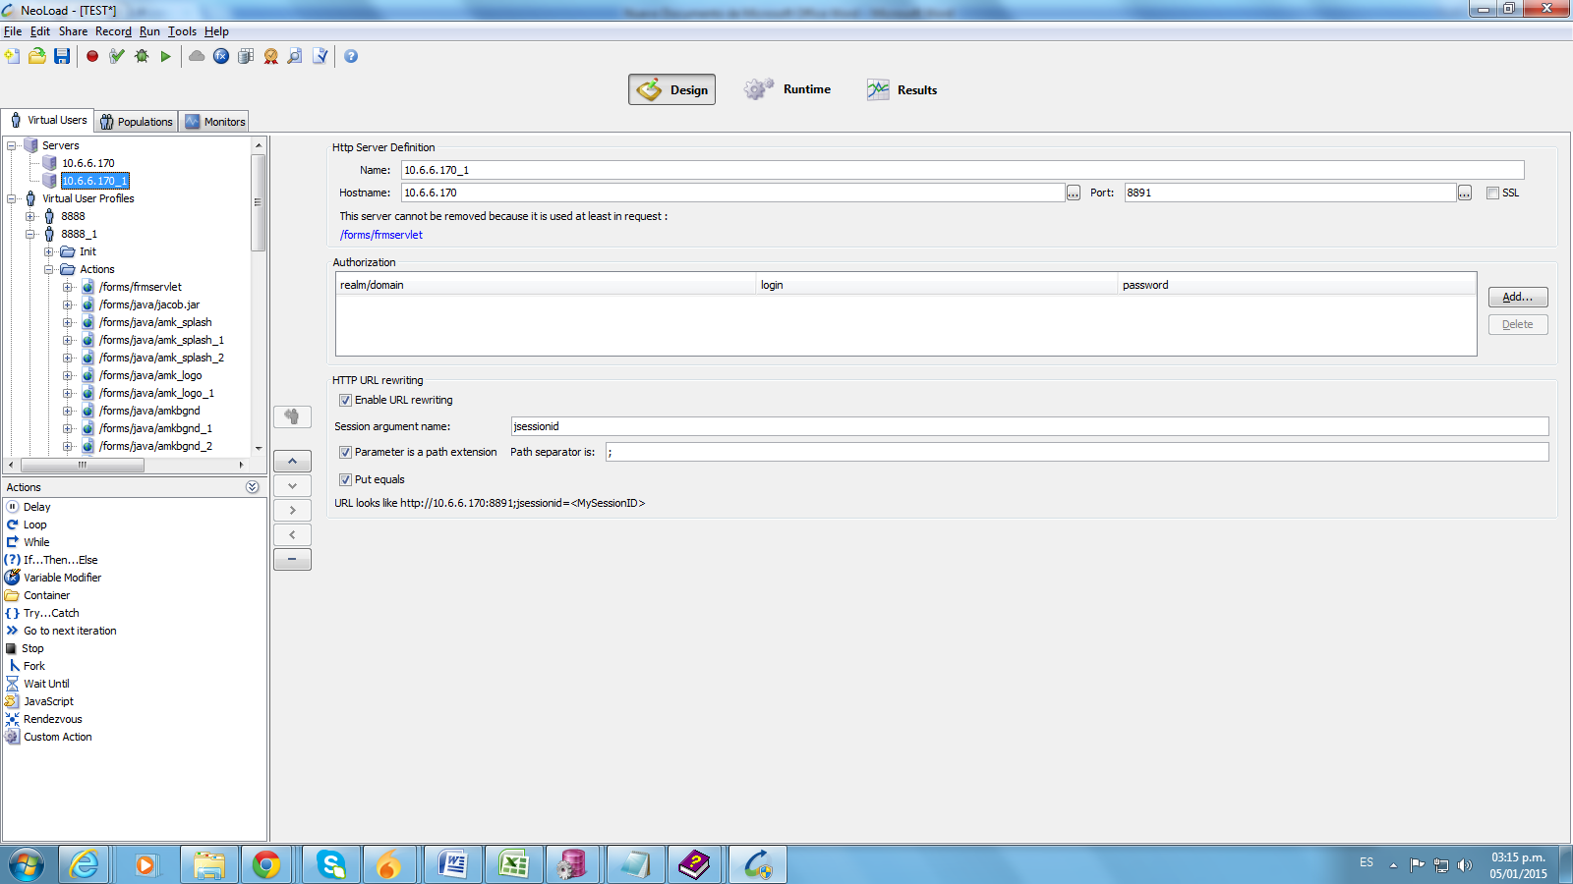
3. We replace the server with the new one

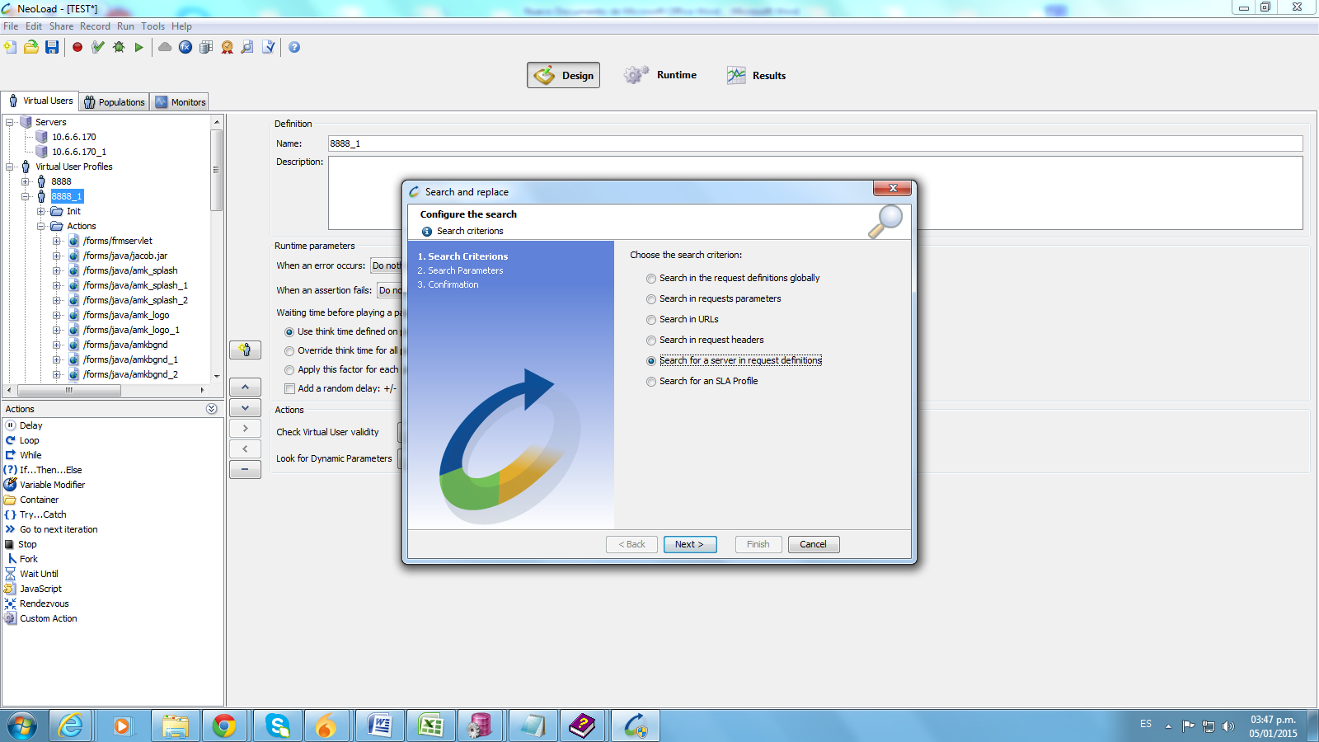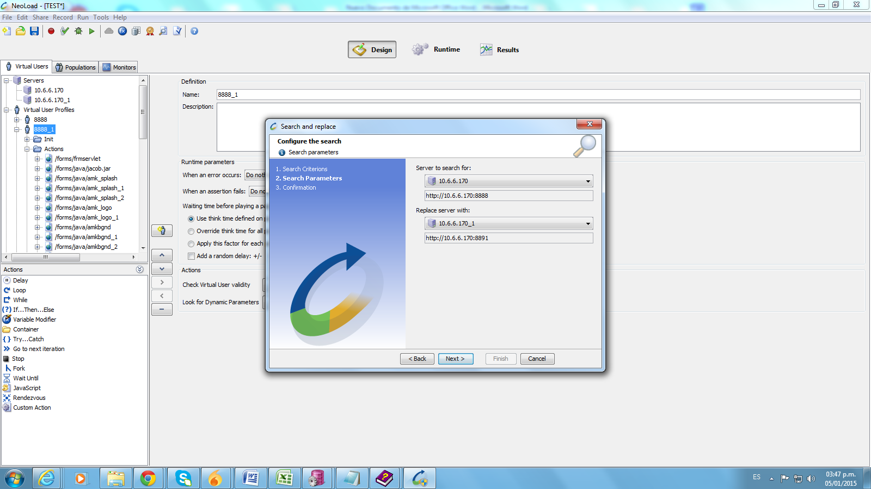
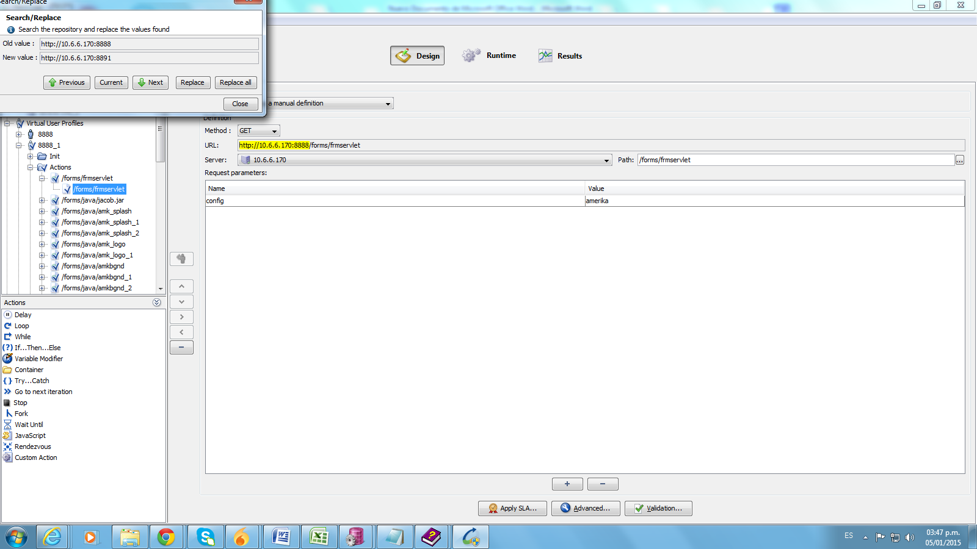
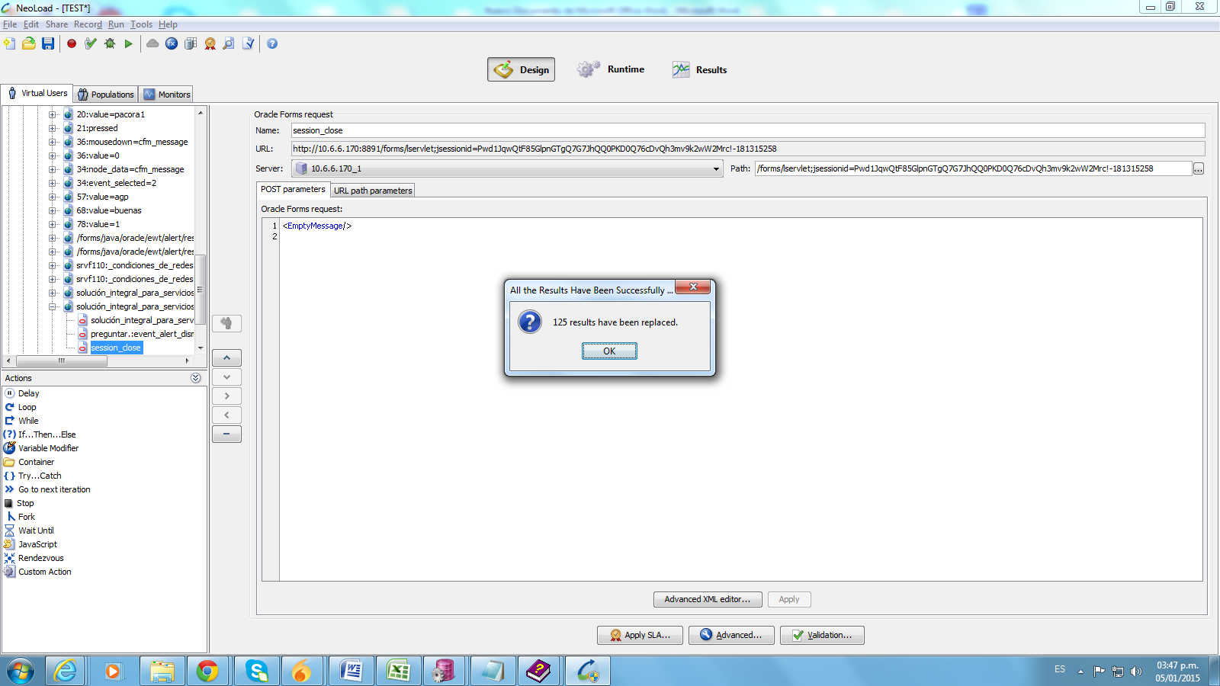
4. We replace the port 8888 with the new one, 8891
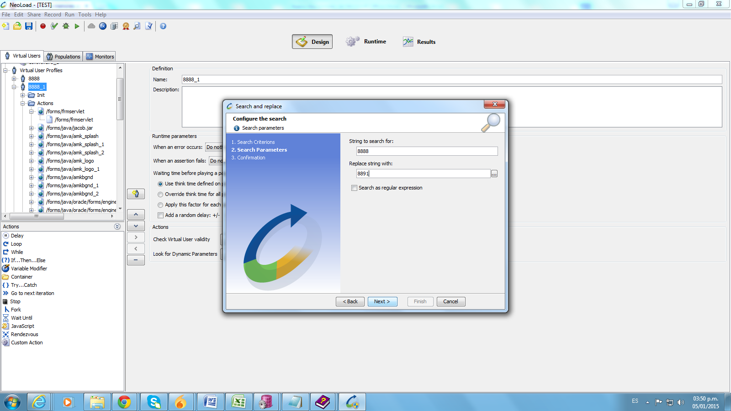
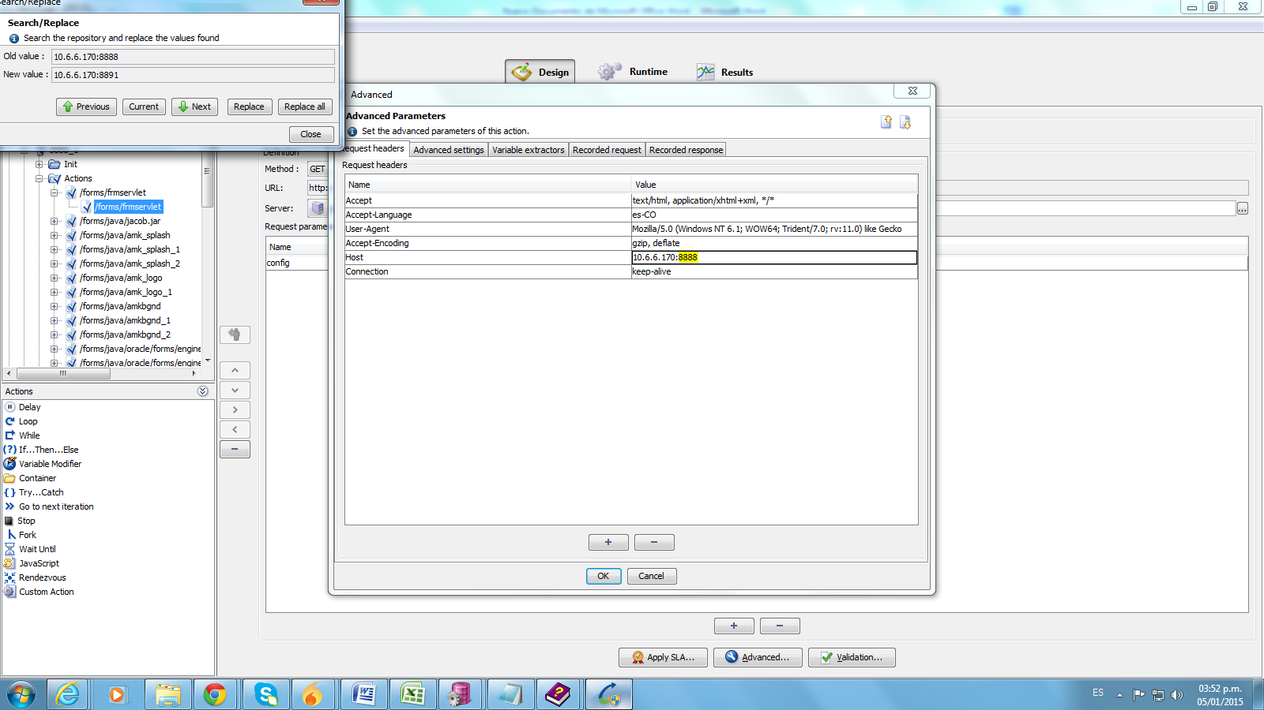
5. We even replace the jsessionid with a new one valid for the new server (we obtained it creating another virtual user with the same steps shown earlier)
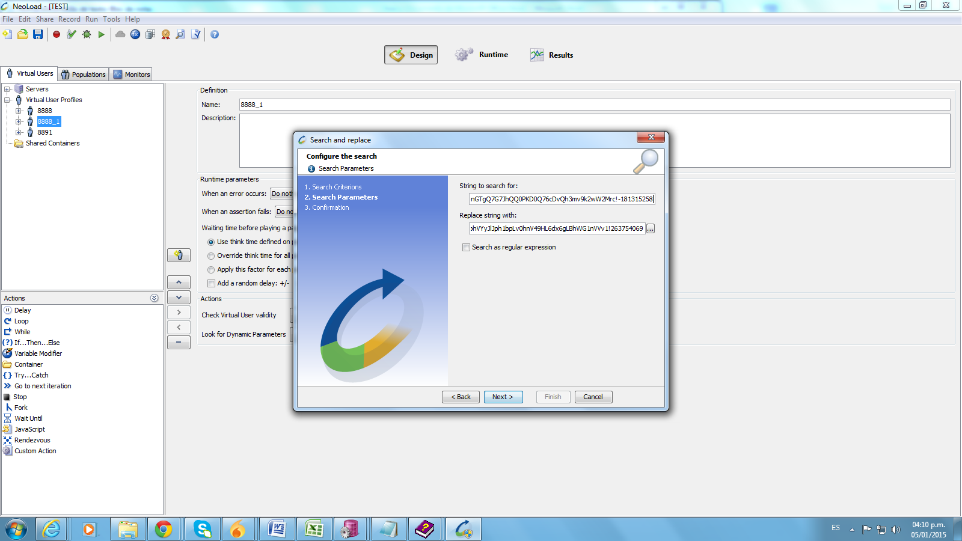
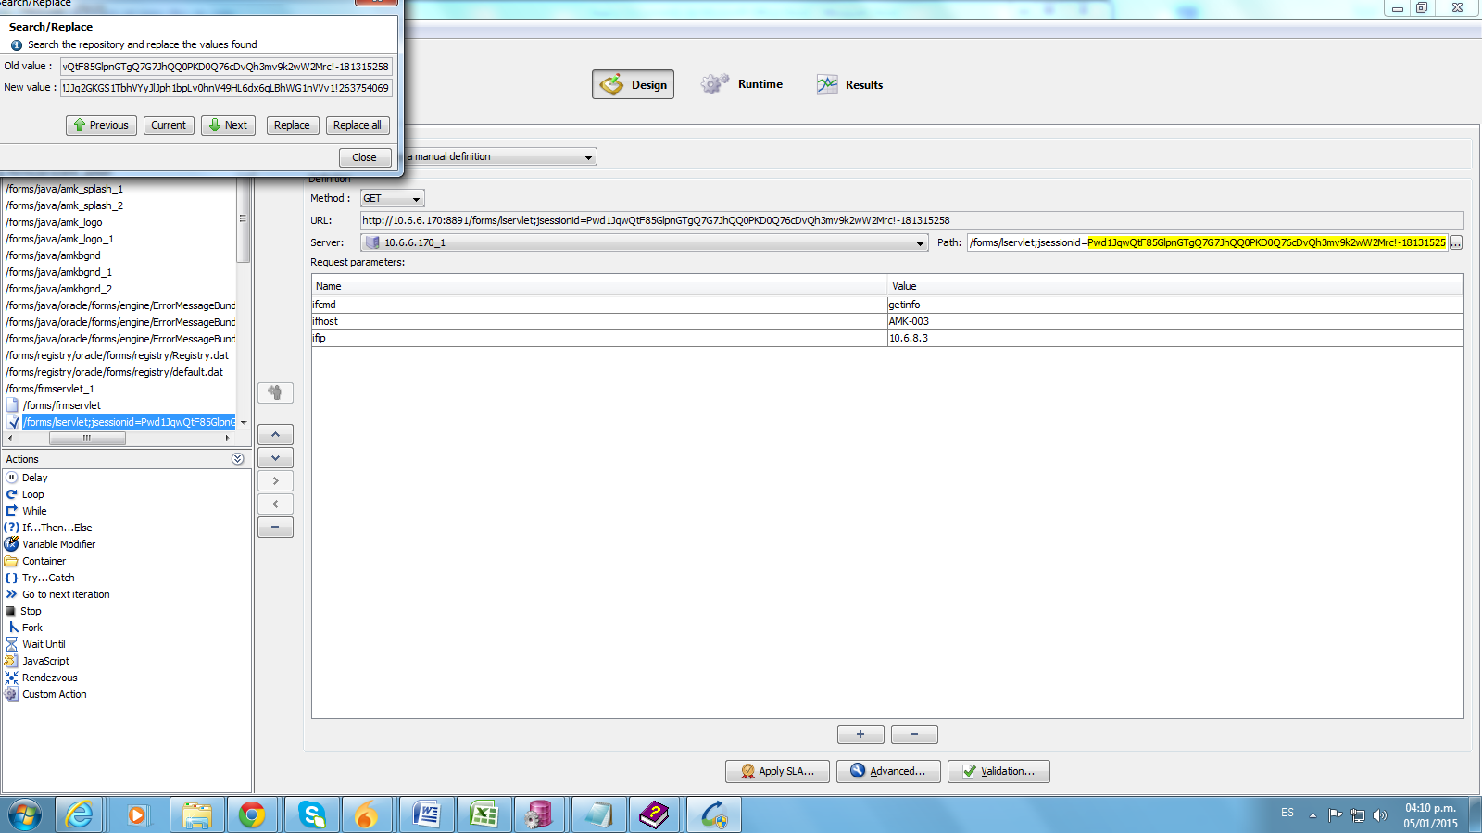
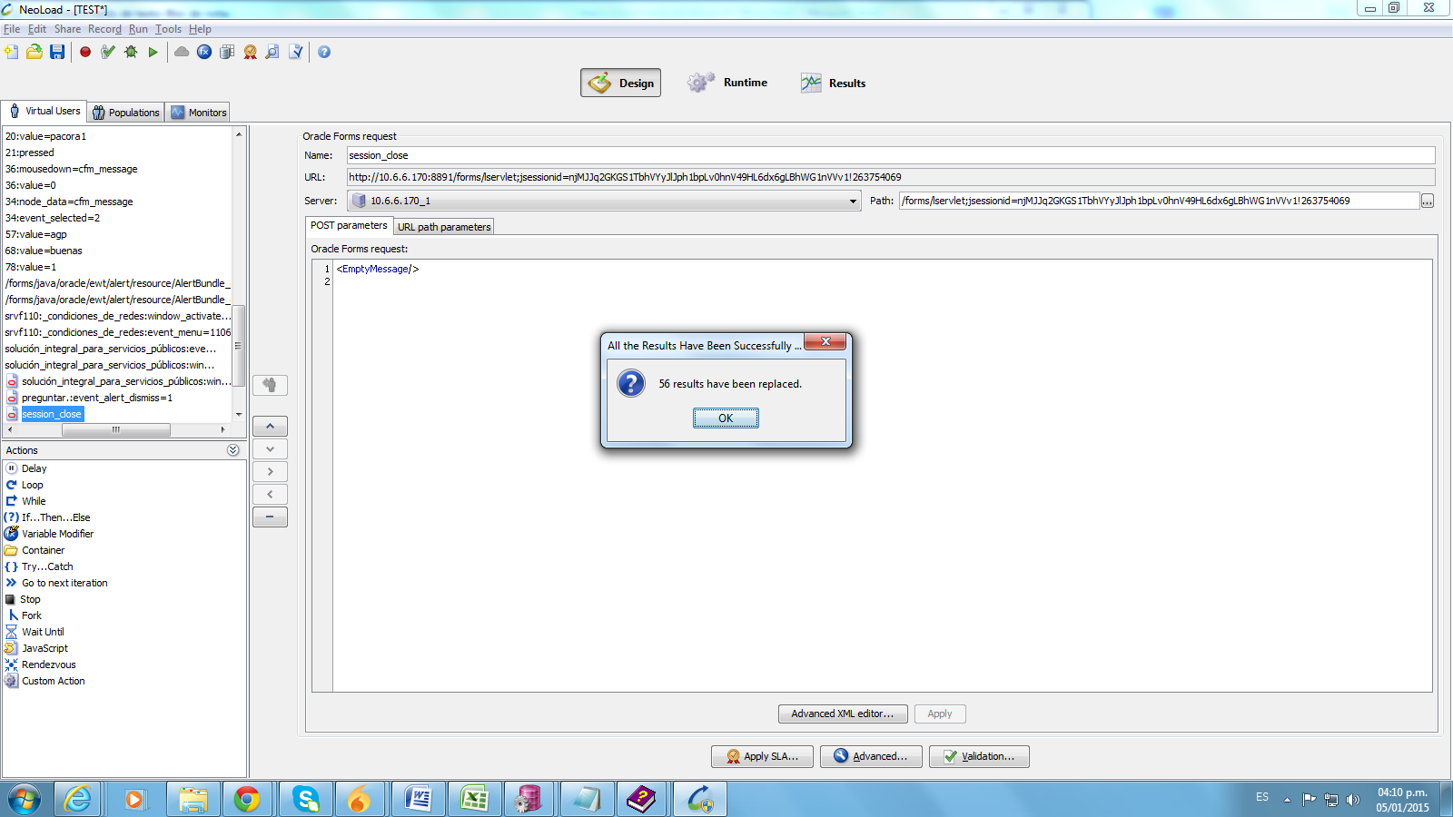
5. We also replace userid and password (This can be handled with variables, but it is not the focus of our test so we just replace them)
6. When we validate the modified virtual user, we get some errors. Most of them are related to unkown handler ids.
