Ask neotys customer support why this is failing…
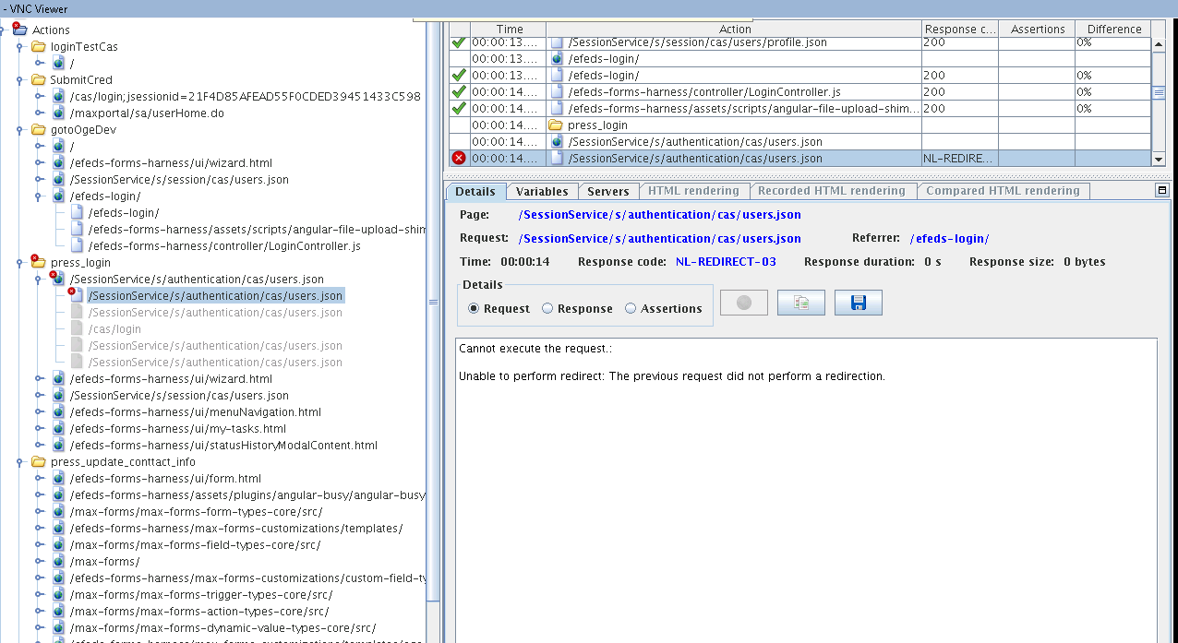

In Design, the script doesn’t show any immediately preceding responses as a 302.

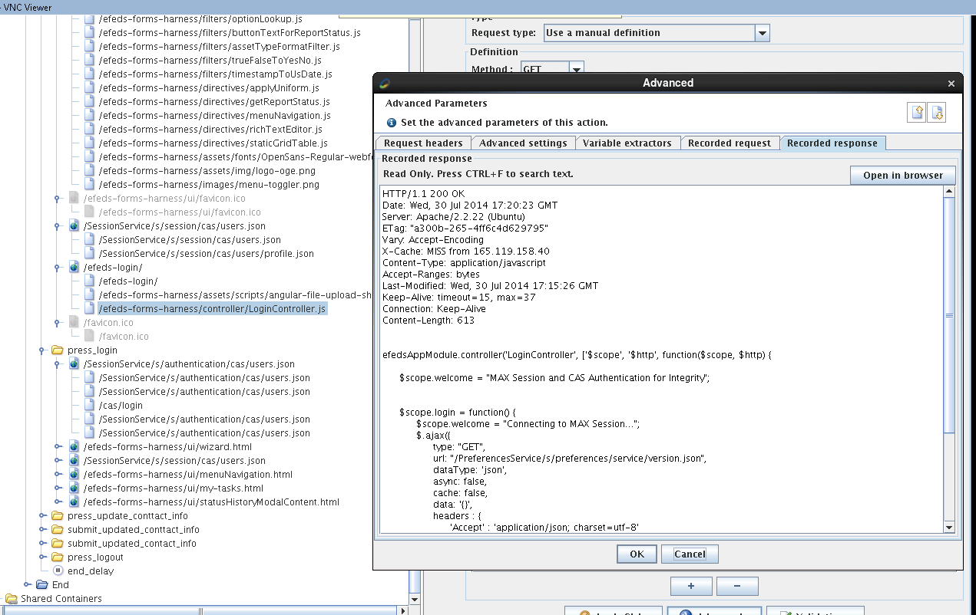
They are all coming back as 200’s in the recorded response.

