DrayTek Vigor 120 settings
192.168.2.1
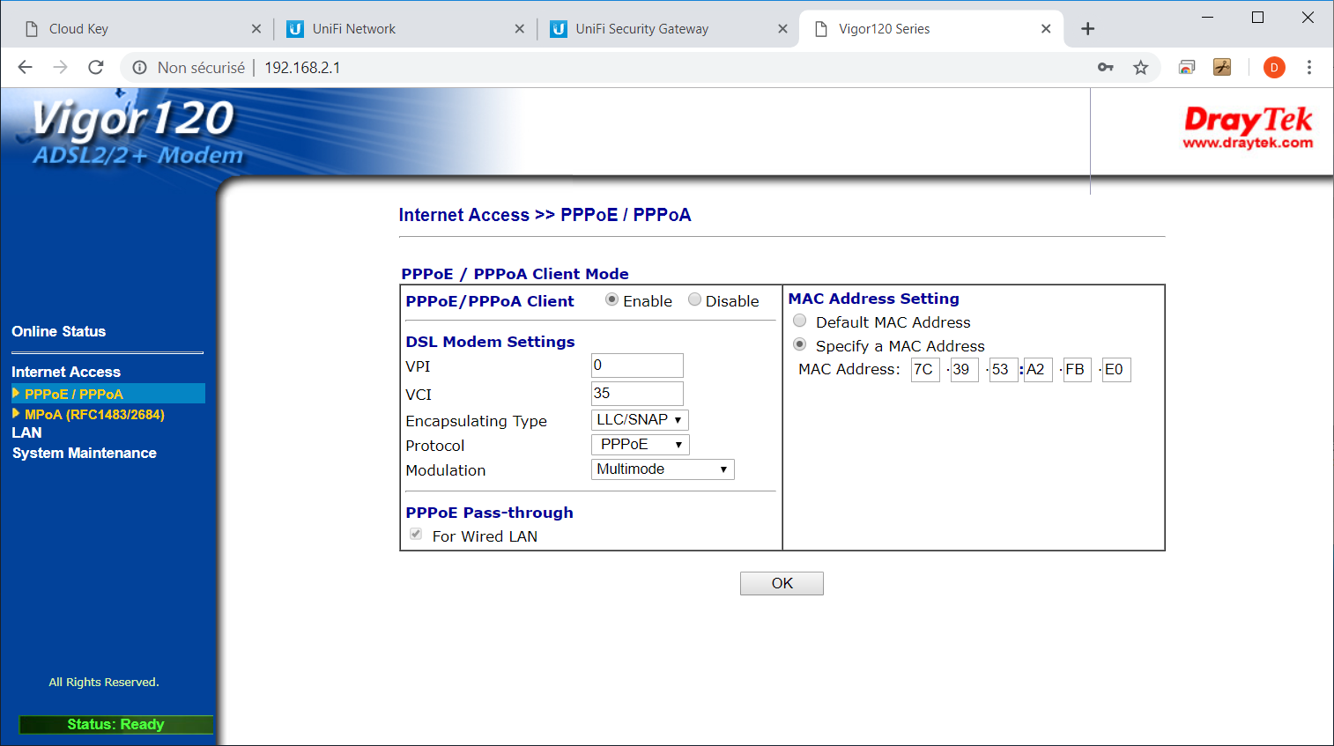

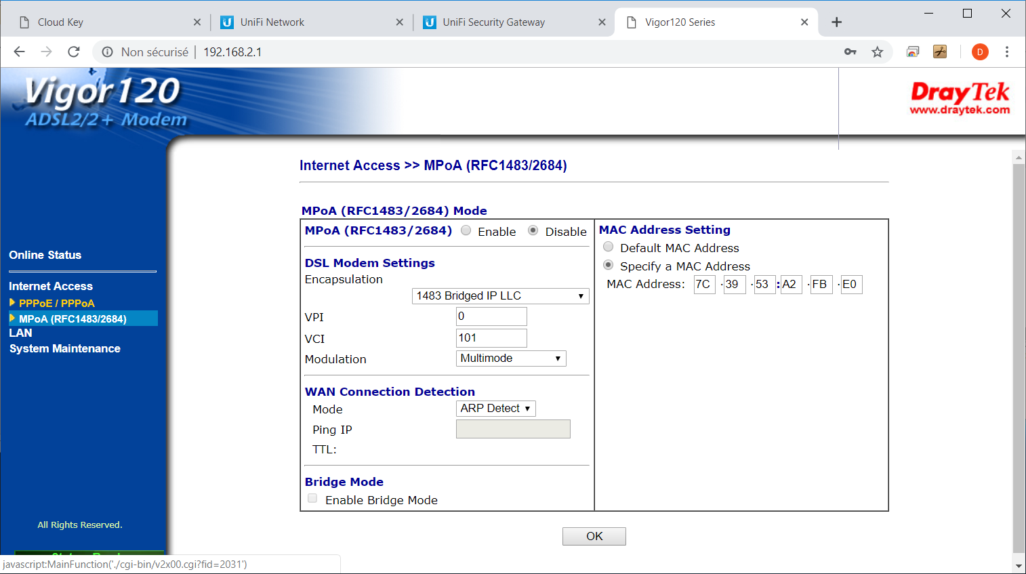

I did not change anything on the following screens to get the internet to work:
I did change them when the internet was working – see later changes section
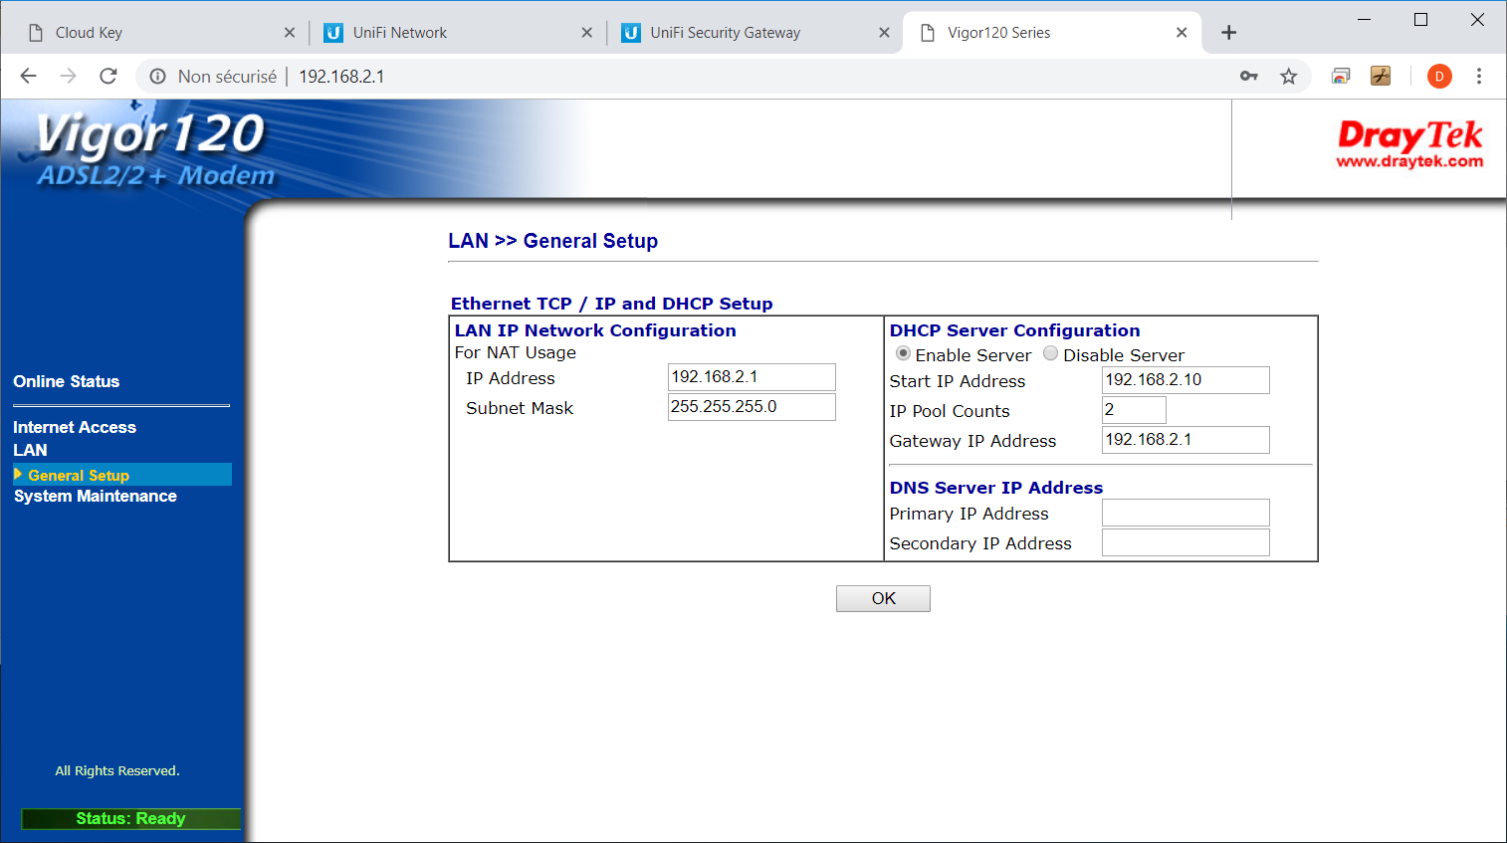

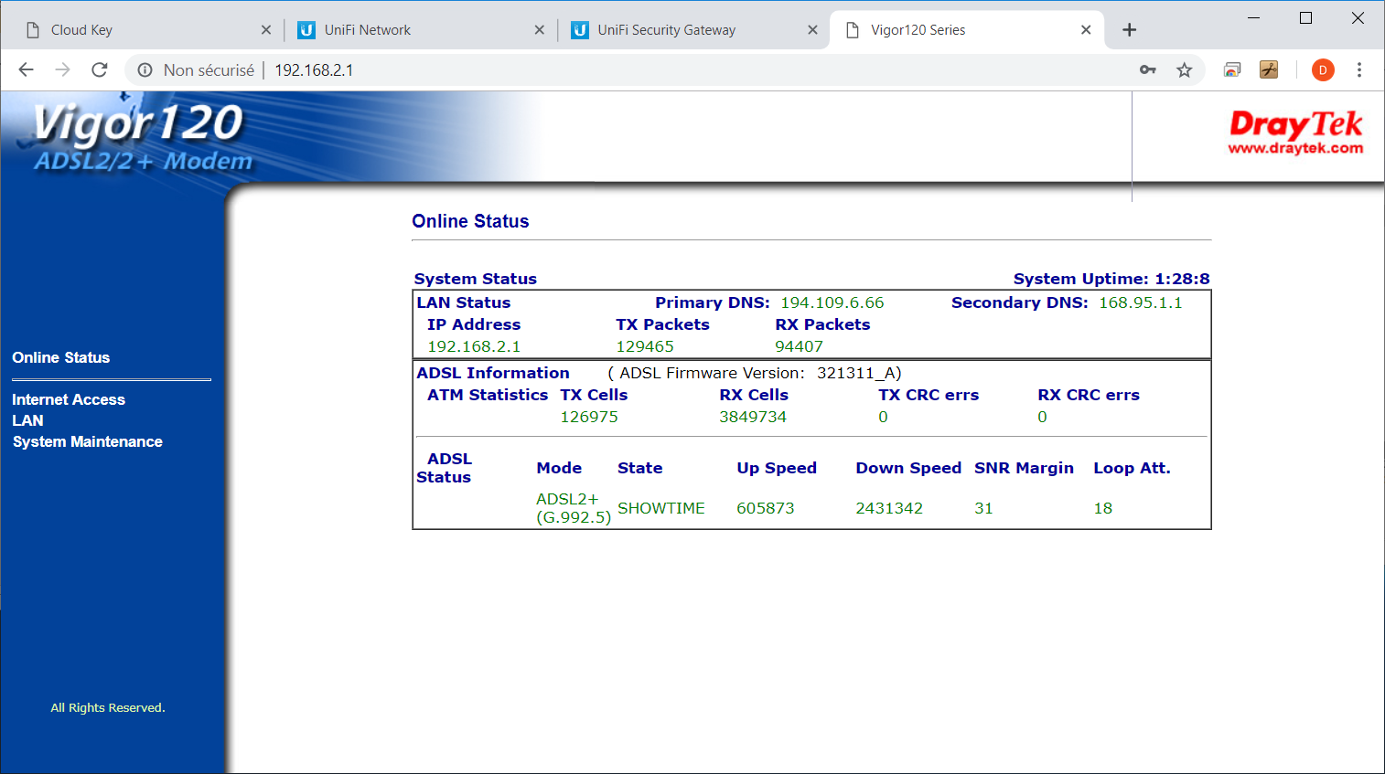
Later I switched off the DHCP server here and switched on the DHCP server on the ubiquiti gateway :
Stqrted zorking qfter q hqrd rest qnd copying settings qbove