Post recording wizard is not prompting and also no elements in Init, Actions and End container after recording.
Http Recorder and IP accessible from client is available
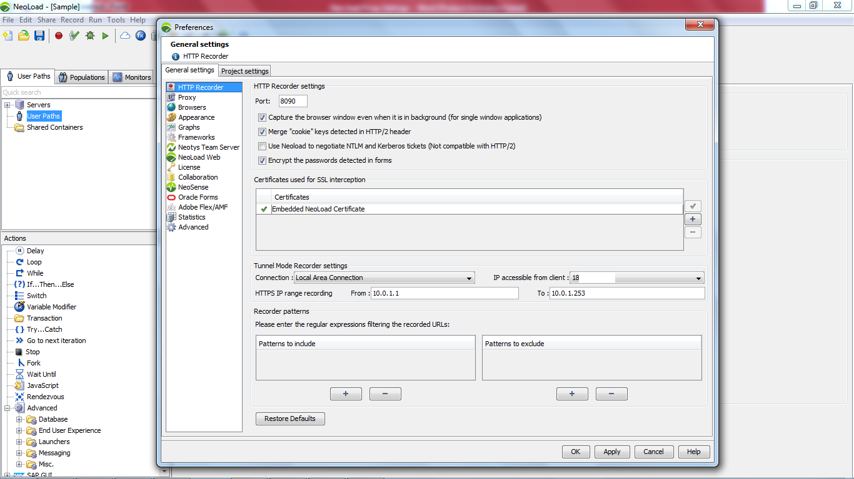

Proxy Settings as “Automatically detect settings” or Manual Settings http -> localhost: 8090
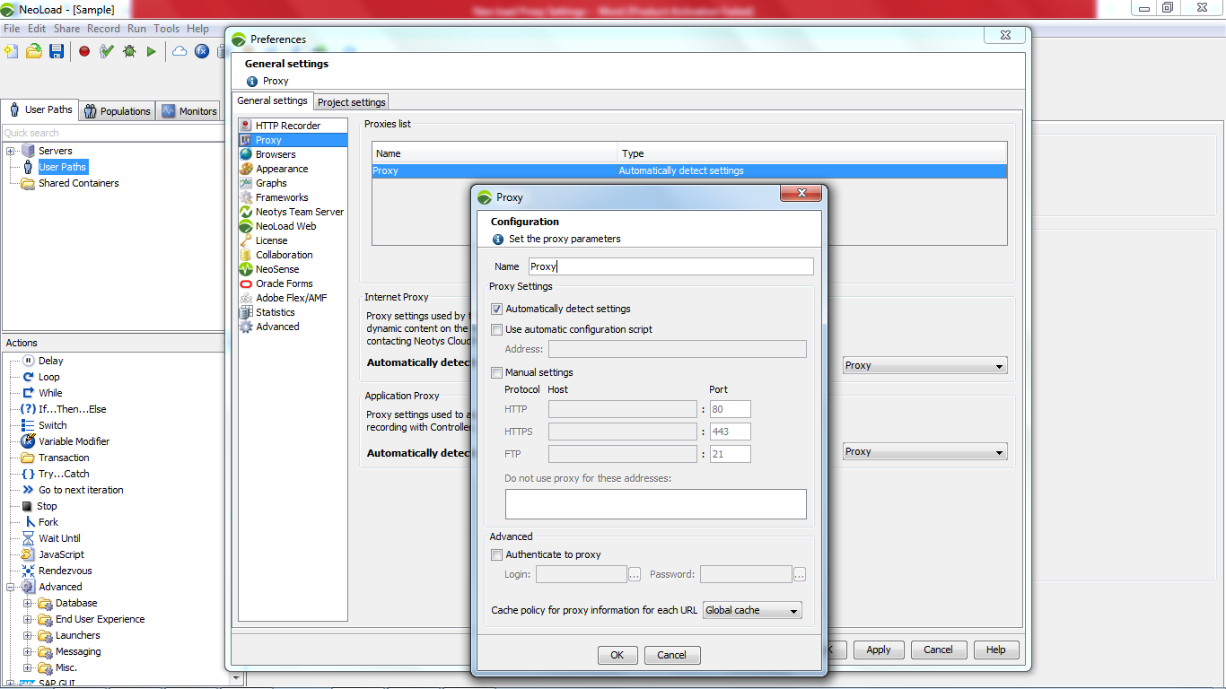

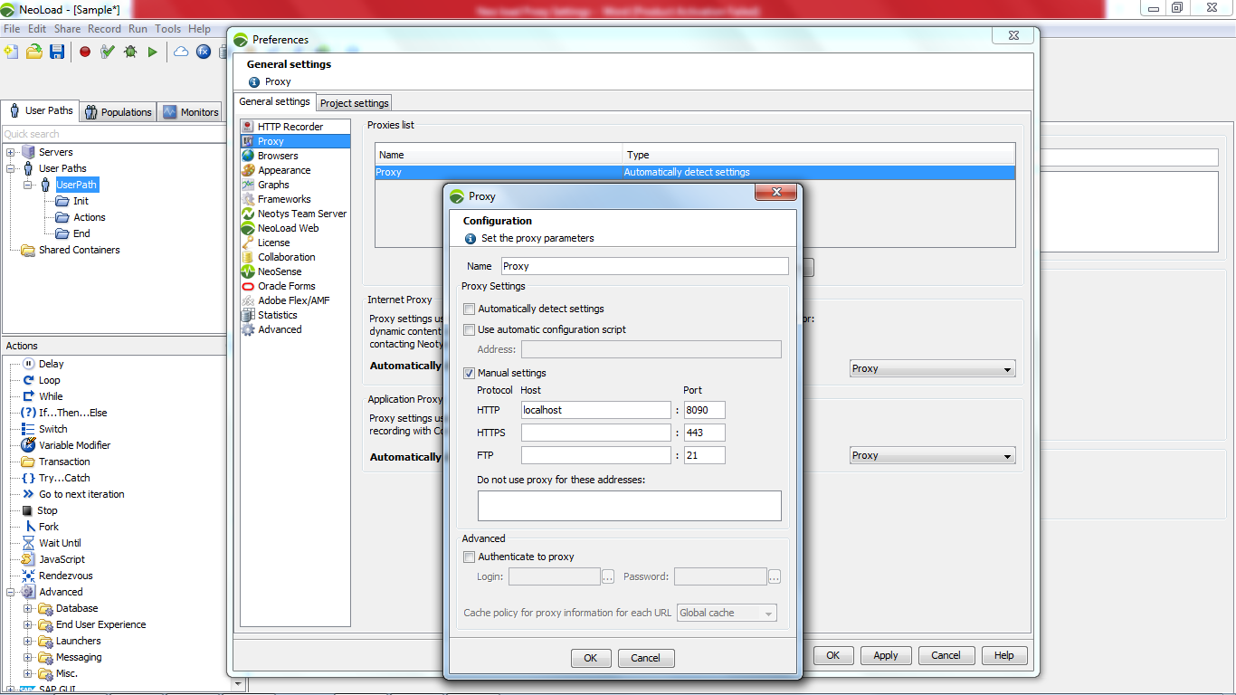

Start Recording
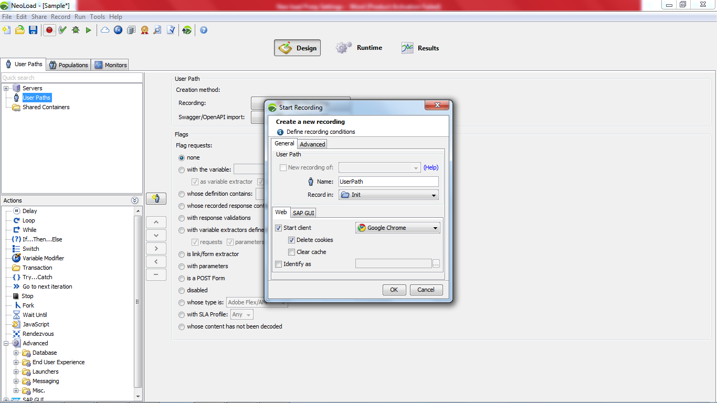

Application Login (Http only) in Init Container
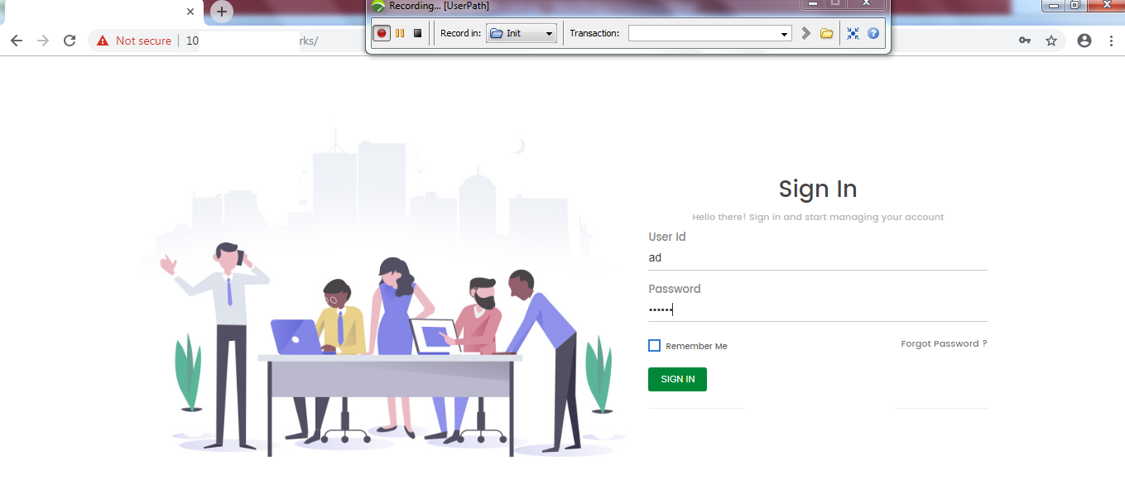
Home page in Init Container
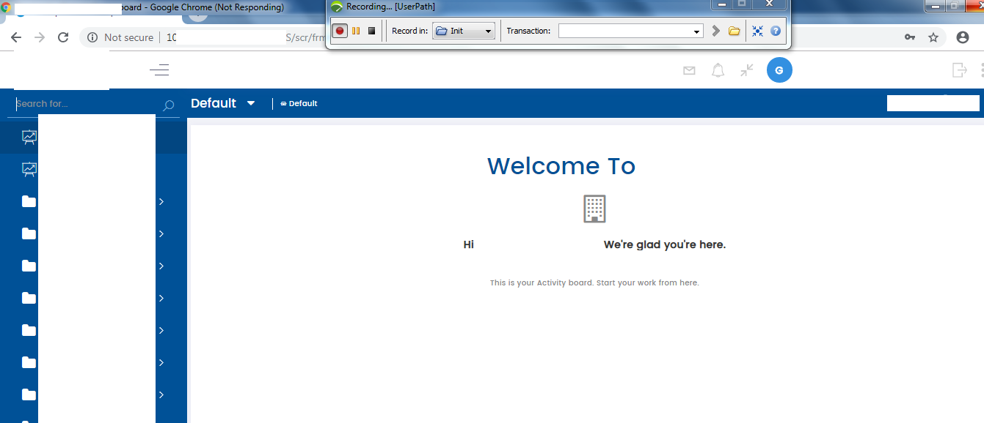
Screen Selection in Actions Container
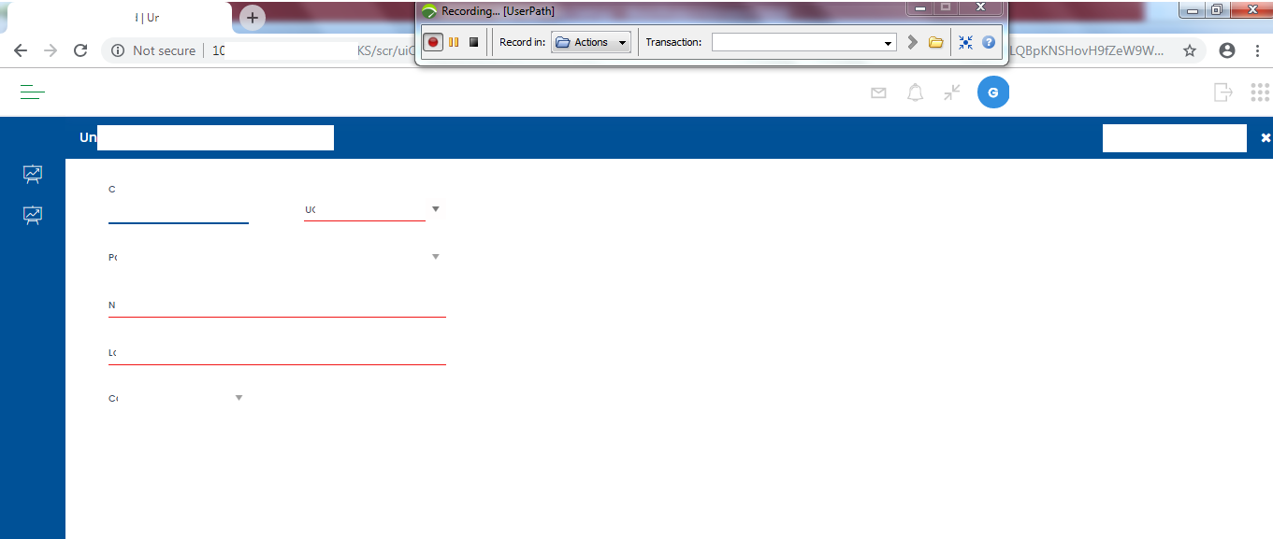

Logout in End Container
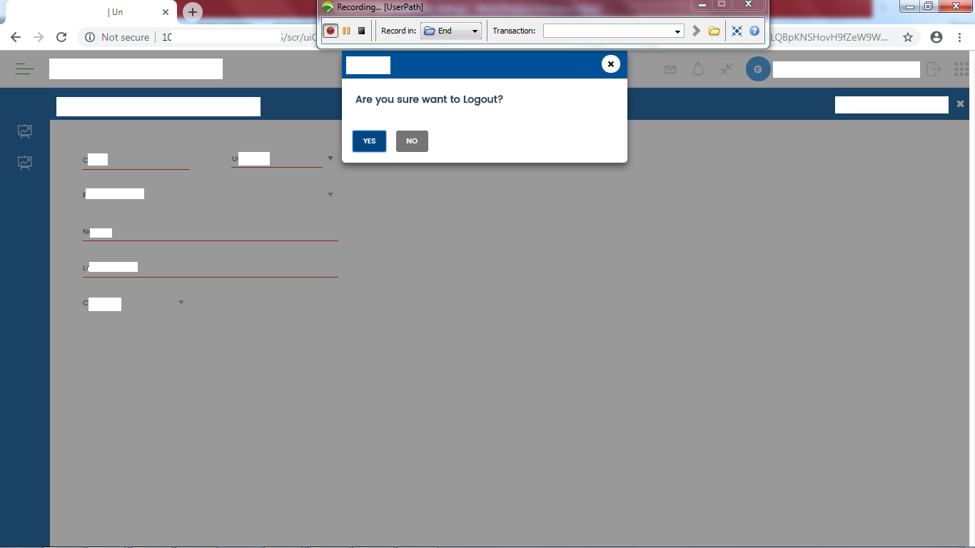

Post recording wizard is not displayed and also no elements in Init, Actions and End Container in User path section after recording for both manual and auto proxy settings.
