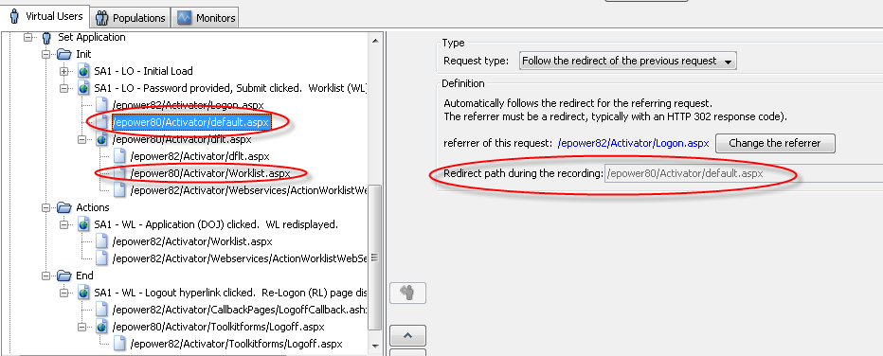
Corrected.
I can’t even change many of these by hand.

PS: If you request more information in your answer, how do I respond to it via your web interface? (I had another question that needed more information for the responder but couldn’t figure out how to provide it to the answer.) (Obviously I’m new to your product and system.)

