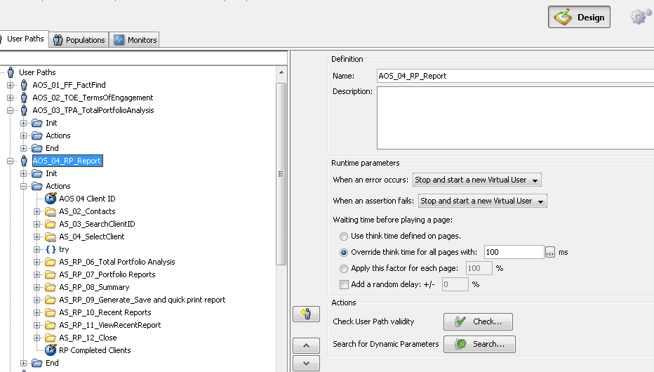

Example of test
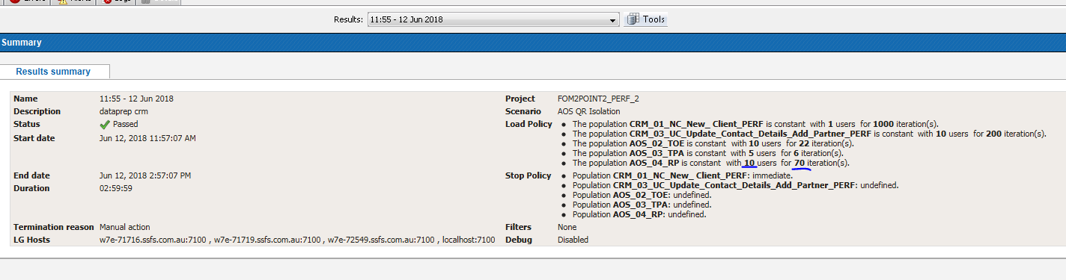
Result transactions- 12 out of expected 700
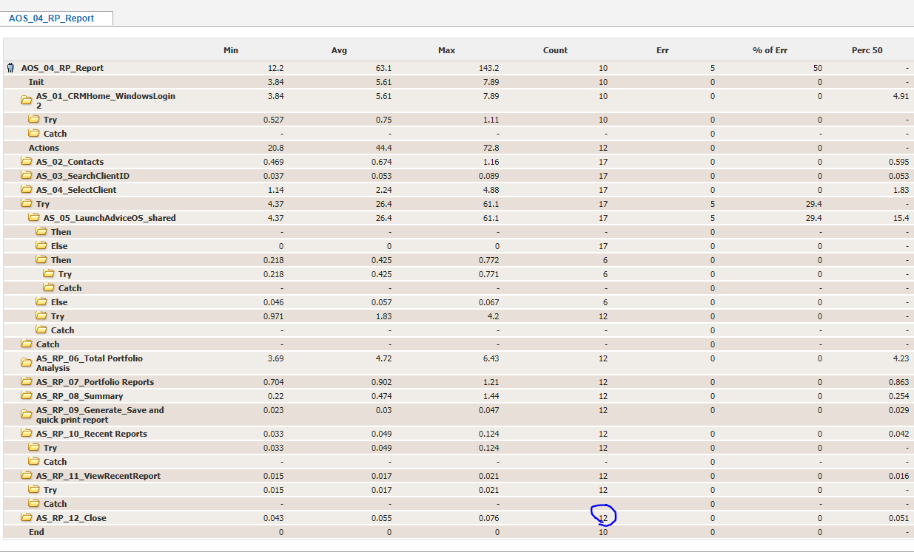
VU user load- some VU’s did mu;tiple iterations, but all eventually trailed off long before completing 70
