NeoLoad Variable in the Text Content of a POST
Using a variable in the text content of a POST the variable does not seem to get substituted. The NeoLoad manual states this which does not seem to be true in 4.2.2:

POST Requests With Text Content
POST requests with a text/... -type content. The contents of these requests may contain NeoLoad variables for generating dynamic content.

When I look at the request in the replay it just shows the variable not the value of it and I get an error. Here is the request with a type of Text and my variable.
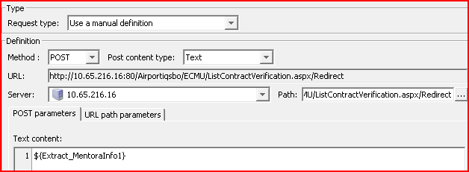
I tried a FORM and put the variable in the Name or the value
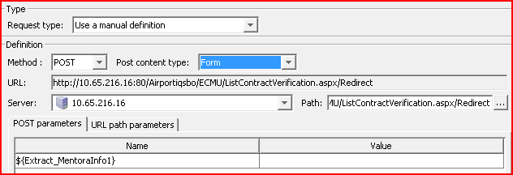
But it wants to put an equals sign before or after depending on which you choose. Here is using the Name, the equals is after and I don’t get the correct response.
