I am trying to create a script for PracTools and having some challenges b/w the SSO security component and Neoload (a Performance Testing tool)  .

Here is the scenario:

Step 1: Access the PracTools (Manual)

While recording using Noeload I get the following nodes:

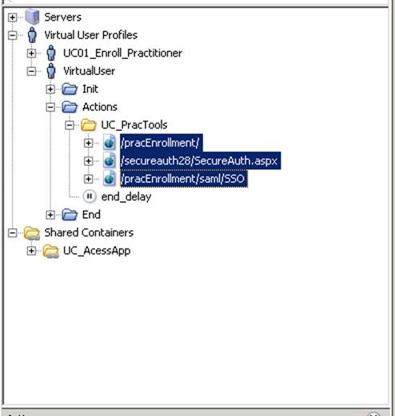

While replaying my script, under the PracEnrollment node the highlighted node is not redirecting to the expected page (PracTools Application) but instead it is redirecting the user to a Single Sign on page. We have already installed the certificate and typically it should redirect us to the security component, authenticate the user and get him to the application. Do you have any thoughts on the issue ? if you need further clarification we can setup a session.

