Having an issue getting the neoload certificate to be trusted on 172.24.14.66.

It’s installed as a root certificate into the firefox browser on 66

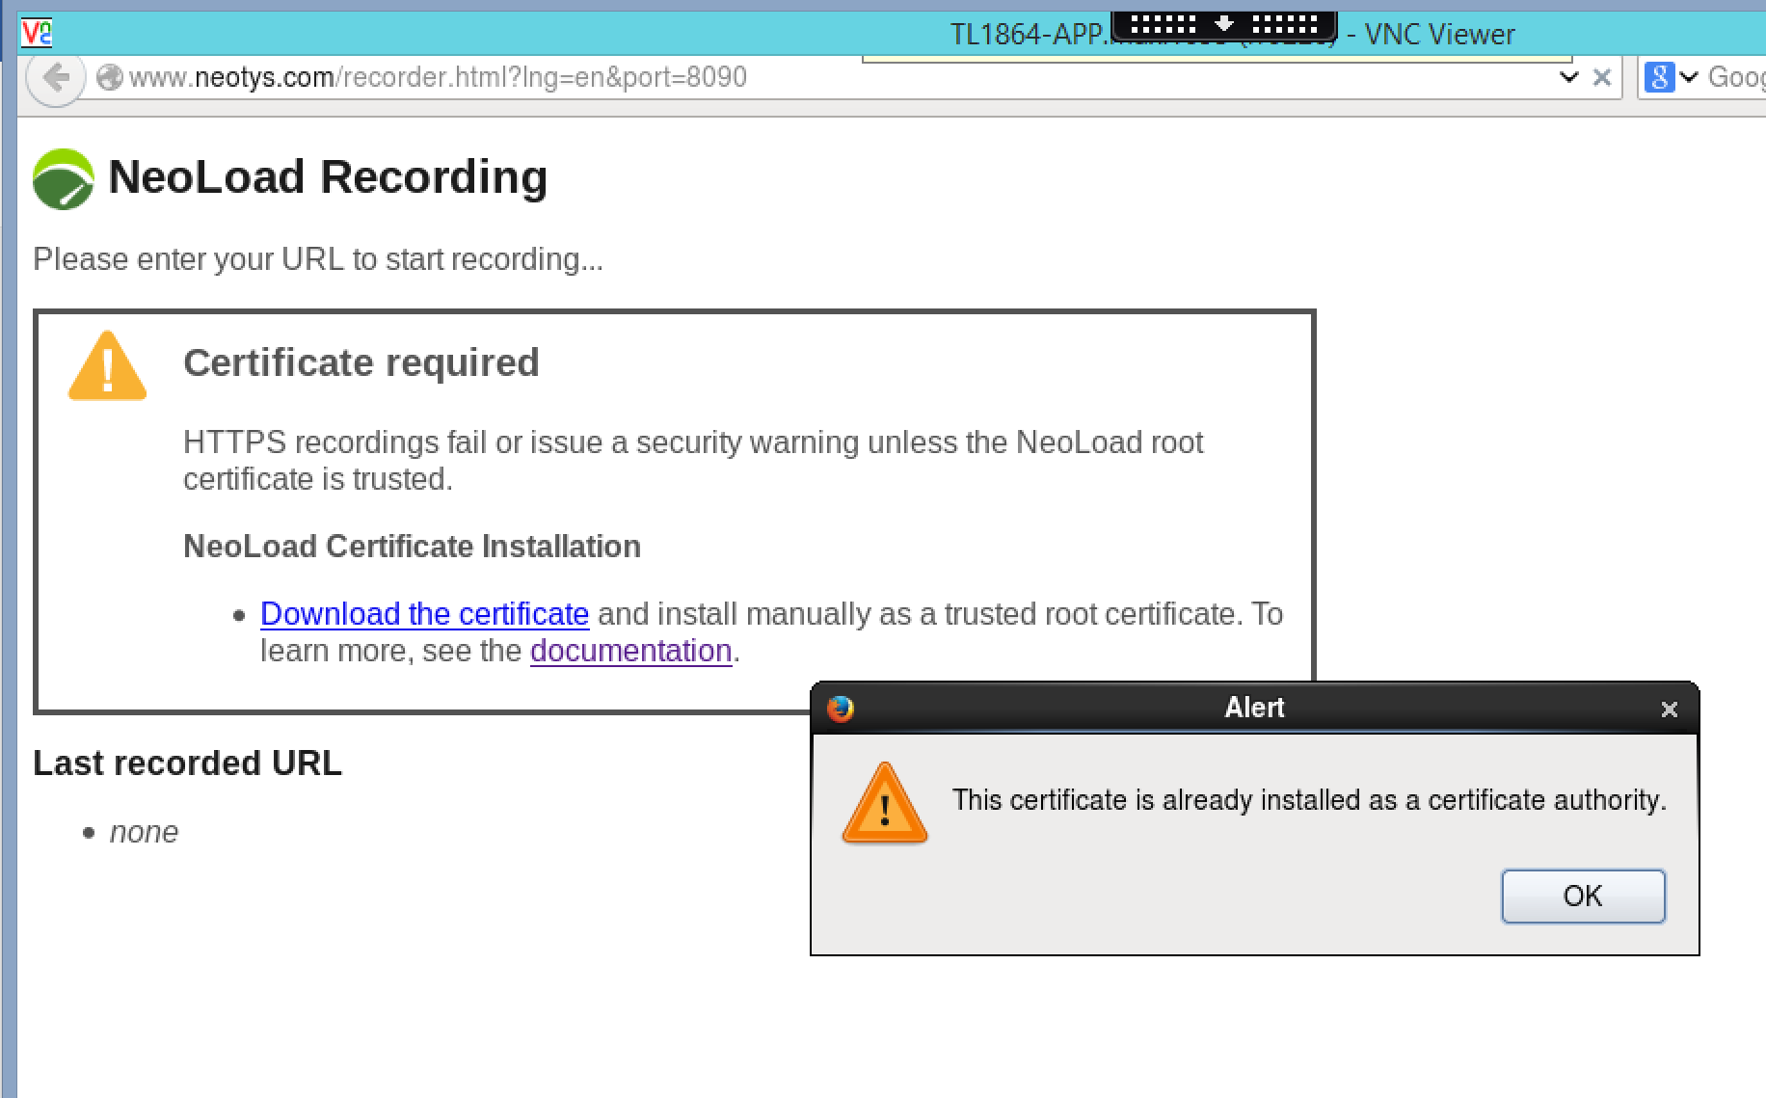
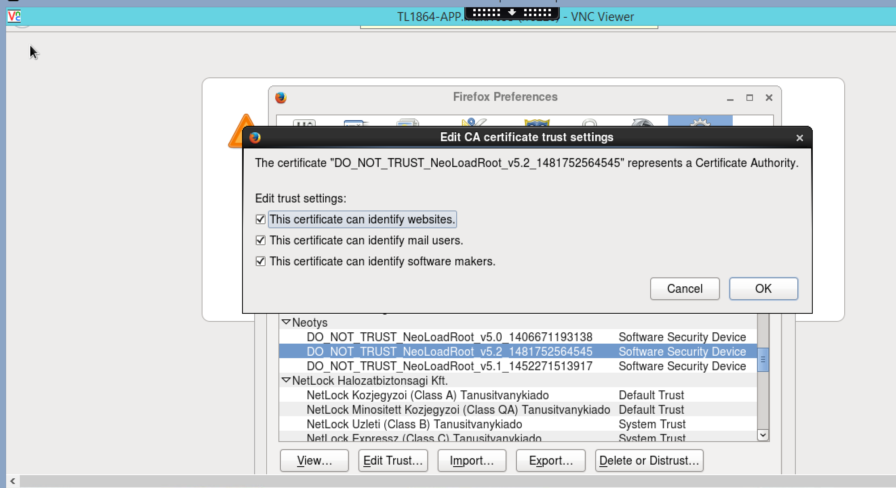’
I can’t record scripts now because the certificate is not being trusted.
Any ideas what needs to be done?

Please let me know.
Thanks!
-Rudy

