- Highlight the script you want to change the server for and then select Edit at the top.

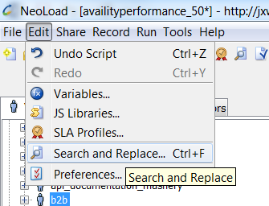
- Select “Search for a Server in request definitions”.
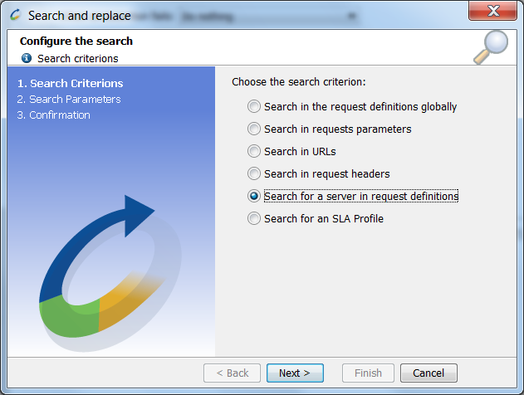
- Select the current server script is pointing to then select the new server the script needs to point to.

